Workshop Monitoring with Prometheus and Grafana

To walk through the steps in this handson instruction, you need an environment with Prometheus, Grafana and Docker Engine. This document describes two approaches that both require Virtual Box on your laptop:

1. Use the fully prepare Virtual Machine

Just import the .ova file into Virtual Box, run the machine and login with vagrant/vagrant

1. Create and run the environment ‘from scratch’ using Vagrant; then connect using ssh

You need to pick one of these two approaches.

# Use the fully prepare Virtual Machine

When the VM is running and you have successfully logged into it, you can skip the next section and turn to the section titled First Run Prometheus.

NOTE: THE VM IS NOT YET AVAILABLE. PLEASE FOLLOW THE SECOND SCENARIO

# Create the environment from scratch

Note: in order to successfully complete these steps, you need to have both VirtualBox (<https://www.virtualbox.org/wiki/Downloads> ) and Vagrant (<https://www.vagrantup.com/downloads.html> ) installed on your laptop.

Clone GitHub Repo <https://github.com/lucasjellema/monitoring-workshop-prometheus-grafana> to your laptop.

## Create Virtual Machine using Vagrant

Open a command line (or terminal) window and navigate to the root directory of the cloned repository. Then run:

vagrant up

This will create and run a Virtual Machine, accessible at IP address 192.168.188.112 and with Ubuntu 18 LTS (Bionic – see <https://wiki.ubuntu.com/BionicBeaver/ReleaseNotes> for release notes) and Docker Engine set up. This step will take several minutes.

Next, run:

vagrant ssh

This will connect you to the Virtual Machine, as user vagrant.

### Download resources

First the Prometheus server. Execute this command:

wget <https://github.com/prometheus/prometheus/releases/download/v2.3.2/prometheus-2.3.2.linux-amd64.tar.gz>

to download the Prometheus server. Then extract the archive using:

tar -xzf prometheus-2.3.2.linux-amd64.tar.gz

Next download the Prometheus (Linux) Node Exporter:

wget <https://github.com/prometheus/node_exporter/releases/download/v0.16.0/node_exporter-0.16.0.linux-amd64.tar.gz>

And extract this archive too:

tar xvfz node_exporter-0.16.0.linux-amd64.tar.gz

Finally, download the alertmanager – a standalone component:

wget <https://github.com/prometheus/alertmanager/releases/download/v0.15.2/alertmanager-0.15.2.linux-amd64.tar.gz>

That also needs to be extracted:

tar xvfz alertmanager-0.15.2.linux-amd64.tar.gz

At this point, all required resources have been added to the Virtual Machine and you are ready to proceed.

# First Run Prometheus

Prometheus is ready to run. It has a minimal configuration at this point – in the prometheus.yml file in directory ~/prometheus-2.3.2.linux-amd64. This file has one scrape-config entry called *prometheus*– one that instructs Prometheus to scrape itself – at port 9090. The application Prometheus exposes metrics for monitoring purposes – to allow administrators to observe the behaviour and health of the Prometheus platform. Prometheus – the same or a different instance - can be used to gather and analyse these metrics.

Navigate to the home directory for Prometheus:

cd prometheus-2.3.2.linux-amd64/

And list the files

ls

You should see the prometheus.yml file. Use

cat prometheus.yml

to inspect the contents of the file. You should find the scrape config for prometheus itself.

Start Prometheus:

./prometheus

This will bring up the Prometheus server that will load and interpret the prometheus.yml configuration file and start acting according to its contents. This means that Prometheus starts scraping he metrics exposed by Prometheus itself.

Open a browser window on your laptop for the URL [http://192.168.188.112:9090/targets](http://192.168.188.111:9090/targets) . This will show a page with all the scrape targets currently configured for this Prometheus instance. There will be only one target shown – Prometheus itself.

The metrics that Prometheus exposes can be inspected in their raw form at [http://192.168.188.112:9090/metrics](http://192.168.188.111:9090/metrics) . Here you will see the metrics that the developers of the Prometheus platform have decided to expose in order to optimize the observability of their platform.

A more pleasing presentation of these same metrics – after scraping and processing by Prometheus – can be seen at [http://192.168.188.112:9090/graph](http://192.168.188.111:9090/graph) .

Check for example the metric *prometheus_http_request_duration_seconds_count* - the running count for the number of measurements of the latency for HTTP requests.

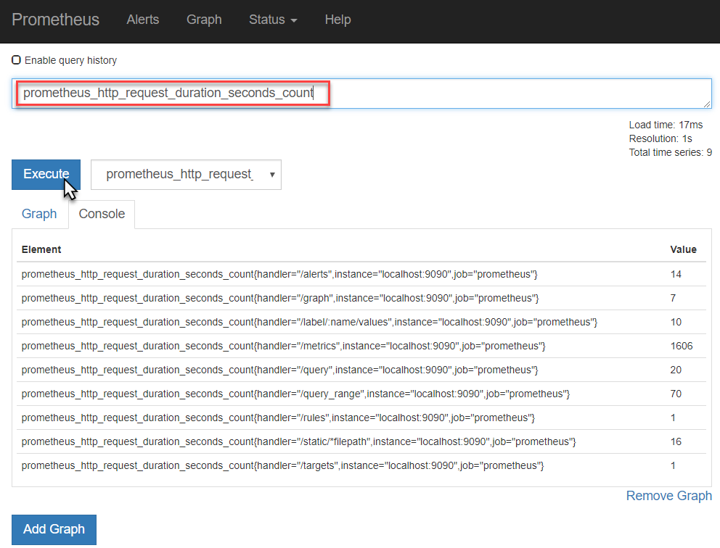

Toggle to the Graph tab to see the evolution over time for this metric – for each of the label combinations. At this point, only the *handler* label has different values for this metric.

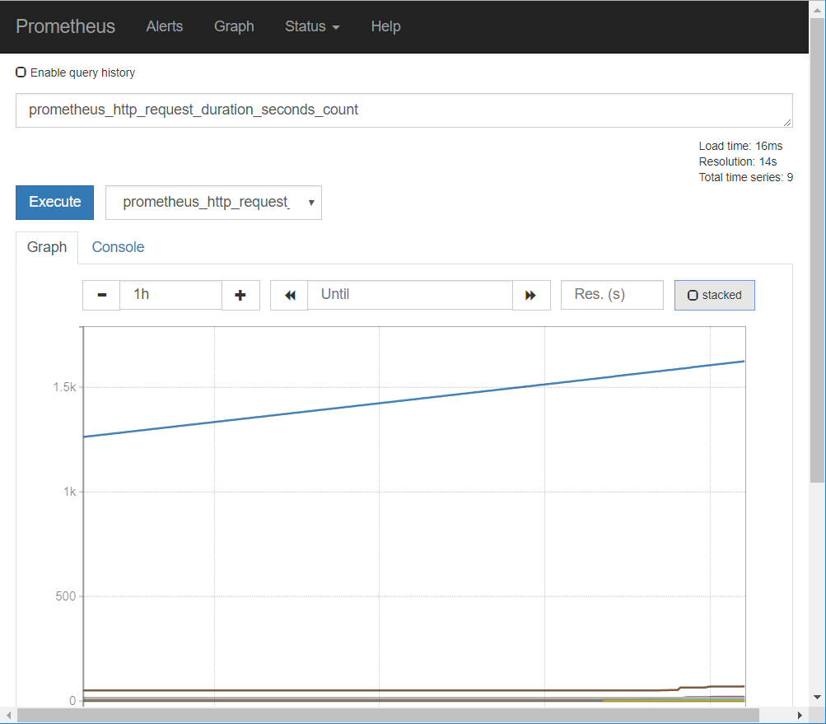

You can toggle between *stacked* and *unstacked* presentation of the data.

Feel free to explore some of the other metrics published by Prometheus – although I fear most are only meaningful to Prometheus experts.

At [http://192.168.188.112:9090/config](http://192.168.188.111:9090/config) you can inspect the contents of the prometheus.yml configuration file.   
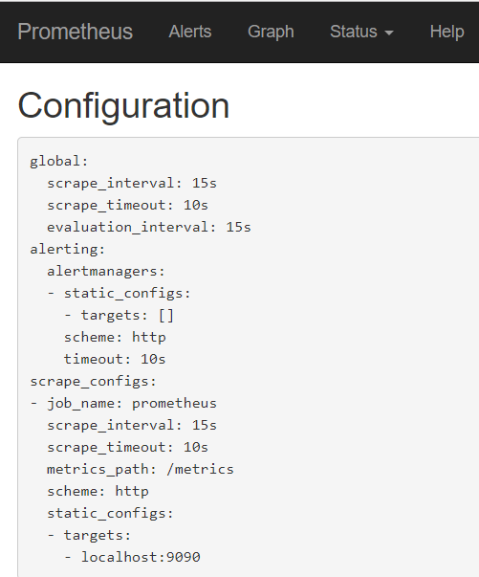  
At [http://192.168.188.112:9090/status](http://192.168.188.111:9090/status) you will see details on this instance of Prometheus - exact version, current runtime status etc.

Stop Prometheus for now – simply by typing CTRL+C in the command line window.

# Make Prometheus scrape Linux server metrics

It is of limited interest at this point to be looking with Prometheus at how Prometheus is doing. More interesting is to monitor a more pressing component, say our Linux server. The Linux operating system sits on any many status indicators and operational metrics – but does not expose them out of the box in a format that Prometheus understands.

The Node Exporter is a component that acts as the adapter between the Linux operating system and Prometheus. When the Node Exporter is running on a Linux system, it exposes an HTTP endpoint (by default this will be /metrics on port 9100) where Prometheus can come to collect all available metrics. It exposes machine-level metrics, largely from your operating system’s kernel, such as CPU, memory, disk space, disk I/O, network bandwidth, and motherboard temperature.

Let’s monitor the Virtual Machine using Prometheus. First, let’s run Node Exporter as a background process (in order to scrape metrics for the Linux system):

cd ~/node_exporter-0.16.0.linux-amd64/

nohup ./node_exporter &

You can check with

jobs

that the node_exporter is indeed running in the background.

In the browser on the laptop host machine, navigate to

[http://192.168.188.112:9100/metrics](http://192.168.188.111:9100/metrics)

This is the endpoint at which the Prometheus Node exporter for Linux publishes its metrics – for Prometheus to scrape. If we can see the raw metrics at this end point, we can now proceed to configure our Prometheus instance to start scraping these metrics.

Return to the command line in the VM. Change directory to ~/prometheus-2.3.2.linux-amd64.

Edit the configuration file prometheus.yml. Add the following snippet under scrape-configs:

- job_name: linux-server-node

static_configs:

- targets:

- localhost:9100

This entry instructs Prometheus to start scraping metrics from the endpoint localhost:9100/metrics – using the global time interval (since no specific interval is specified for this job). This endpoint – as we have seen for ourselves – is the endpoint where the node_exporter publishes the Linux metrics.

Now start Prometheus Server

./prometheus

In the browser on your laptop, navigate to [http://192.168.188.112:9090/targets](http://192.168.188.111:9090/targets) . You will see the targets from which your Prometheus instance is scraping metrics. In addition to Prometheus target that we saw before, we now also should see the linux-server-node.

Open the Graph tab – or navigate to [http://192.168.188.112:9090/graph](http://192.168.188.111:9090/graph) . Open the dropdown next to the Execute button. You will now see a list of all the metrics currently available in the metrics store of your Prometheus instance.

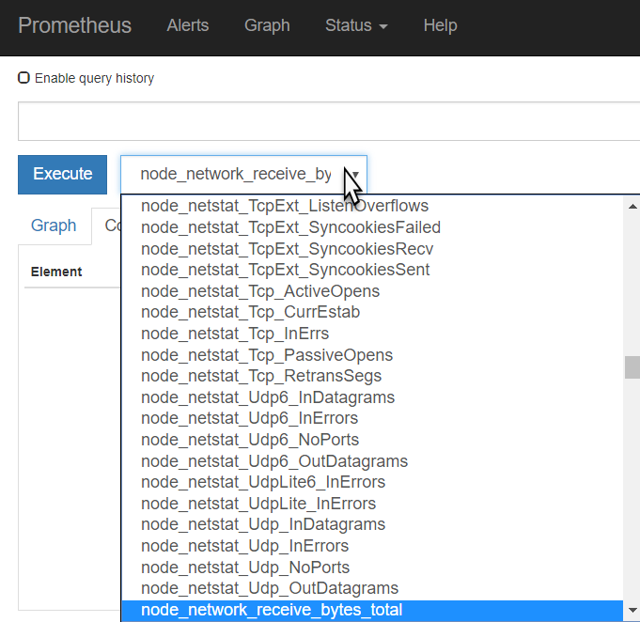

Select the metric called *node_network_receive_bytes_total* and press Execute.

This will list the total number bytes received over each of the network devices for the Linux server in the VM.

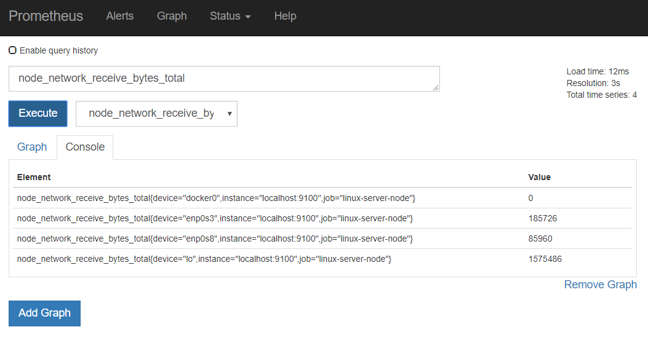

Press Graph to get a graphical representation of these values and their evolution over time:

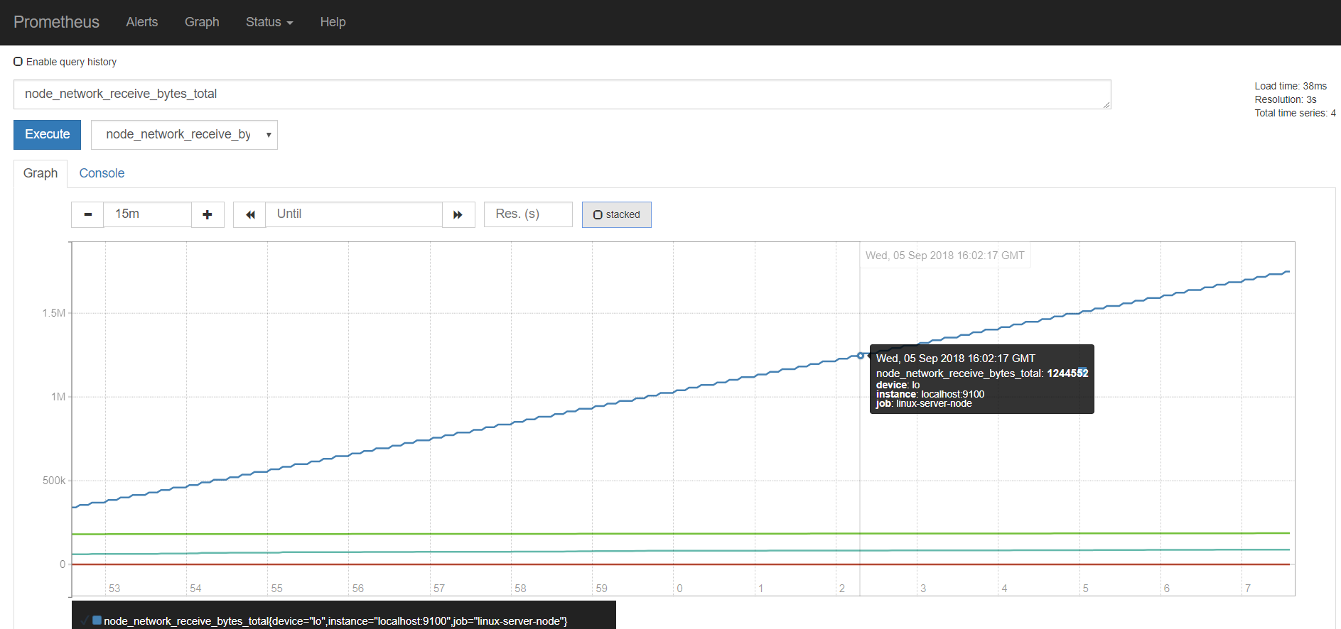

Using wget to download some additional files should have an effect on this metric.

Feel free to inspect some of the other metrics available from the Linux system – such as

* node_cpu_seconds_total (a counter indicating how much time each CPU spent in each mode)
* node_filesystem_size_bytes and node_filesystem_avail_bytes (gauges indicating the total filesystem size and the available sizes).
* node_memory_MemFree_bytes - the amount of memory that isn’t used by anything

## Quick intro to PromQL

In addition to inspecting and visualizing the values of metrics, the Prometheus Web UI also allows us to use PromQL – the Prometheus query language. This allows us to perform calculations with metrics – resulting in more meaningful values than just the bare metrics themselves.

For example, enter the following PromQL expression in the input field

time() - node_boot_time_seconds

and press execute. The resulting value is how long the kernel has been up. The result of an expression can both be presented in tabular format and as a graph.

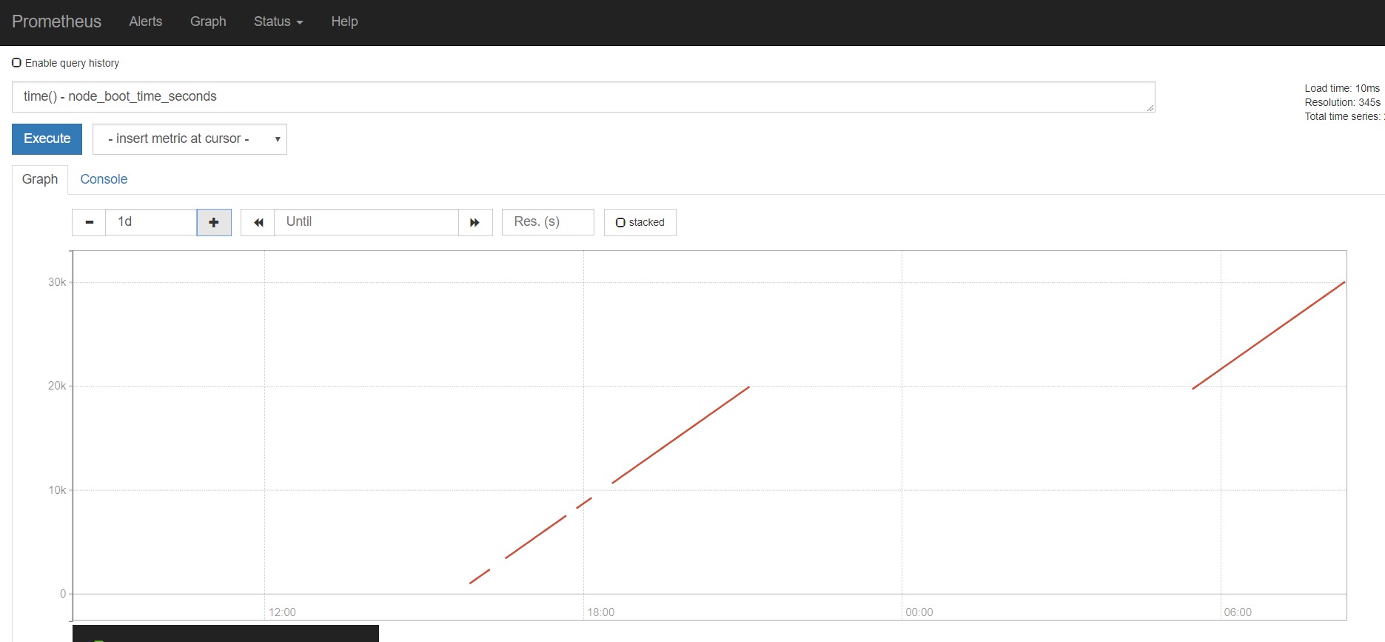

Try this expression

rate(node_network_receive_bytes_total[1m])

It tells you about the bandwidth used up by each network device – by calculating the change rate in the total number of bytes received. Do another wget operation to create some network traffic.

And :

avg without(cpu, mode)(rate(node_cpu_seconds_total{mode="idle"}[1m]))

the proportion of idle time across all CPUs . This works as it calculates the idle time per second per CPU and then averages that across all the CPUs in the machine.

If you want to know the proportion of idle time for each CPU, then remove cpu from the without expression:

avg without( mode)(rate(node_cpu_seconds_total{mode="idle"}[1m]))

See https://prometheus.io/docs/prometheus/latest/querying/basics/ for more details on PromQL and the operators and functions at our disposal.

See https://prometheus.io/docs/guides/node-exporter/ for details on the Node Exporter and all metrics it exposes.

# MySQL Exporter

To give you a taste of what using Exporters for third party applications and platform components looks like, we will now run a MySQL server instance in a Docker container, then attach a MySQL Exporter for Prometheus to this instance and scrape the MySQL metrics in our Prometheus server.

First, to run the MySQL server instance, execute this command:

docker run --name mysql-db -e MYSQL_ROOT_PASSWORD=my-secret -d mysql:8

Note: this will cause quite some network traffic - if you started with a fresh image using Vagrant– which you can easily verify in the Prometheus Console by inspecting the metric *node_network_receive_bytes_total*.

You can connect to this MySQL instance using this command – but for the purpose of these practice steps you do not have to:

docker run -it --link mysql-db:mysql --rm mysql sh -c 'exec mysql -h"$MYSQL_PORT_3306_TCP_ADDR" -P"$MYSQL_PORT_3306_TCP_PORT" -uroot -p"my-secret"'

and execute MySQL command line statements such as:

show databases

Next, run the Prometheus Exporter for MySQL, in its own Docker container:

docker run --name mysql-exporter -d \

-p 9104:9104 \

--link mysql-db:mysql \

-e DATA_SOURCE_NAME="root:my-secret@(mysql:3306)/" \

prom/mysqld-exporter

To make the Prometheus server scrape the metrics from the MySQL Exporter, we have to add the following entry to the prometheus.yml file:

- job_name: 'mysqld'

static_configs:

- targets:

- localhost:9104

This instructs Prometheus to check the /metrics endpoint at port 9104 on the localhost – which is mapped to port 9104 in the container running the MySQL Exporter.

After restarting the Prometheus server, you will find that MySQL has been added as a target:

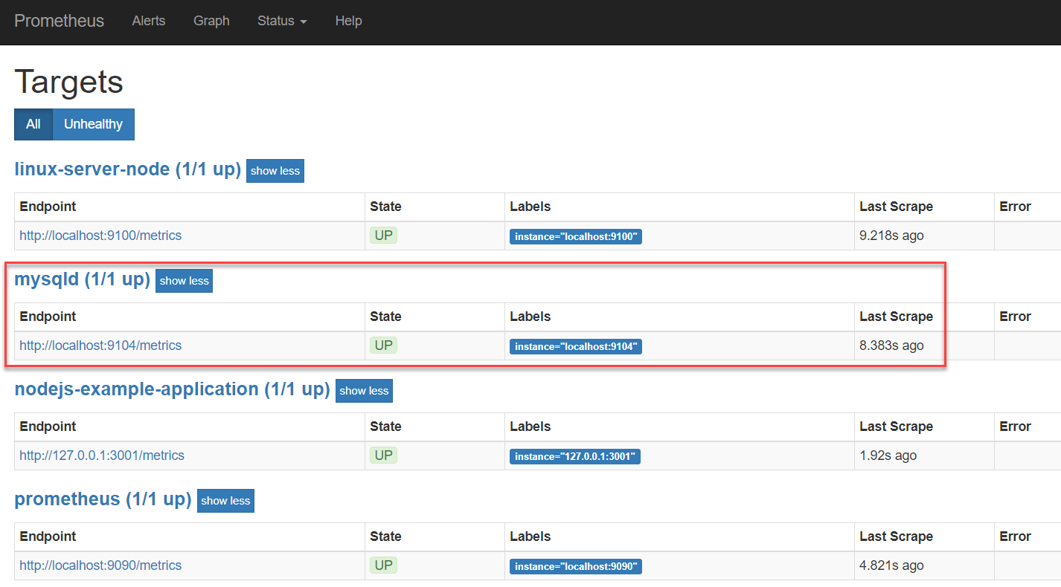

And that now MySQL Metrics are available in the Prometheus UI.

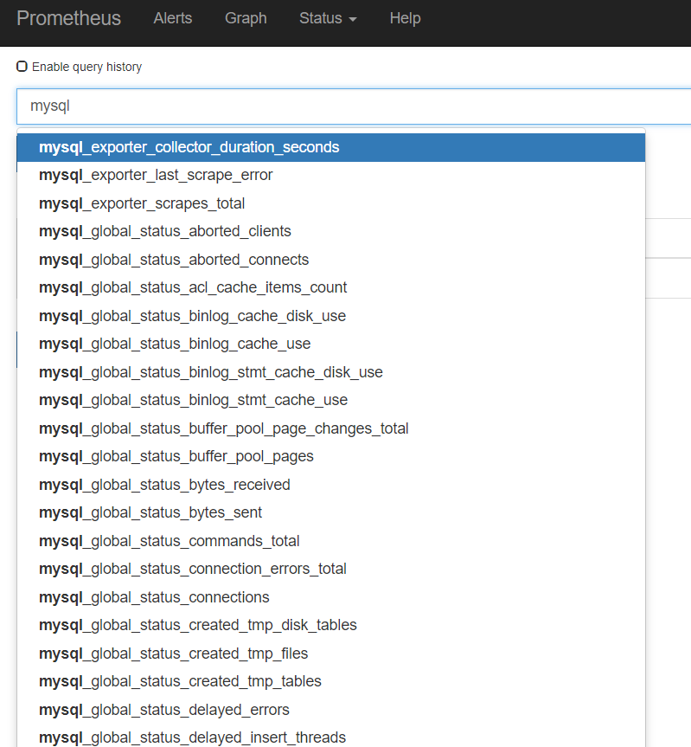

Check for example the number of connections:

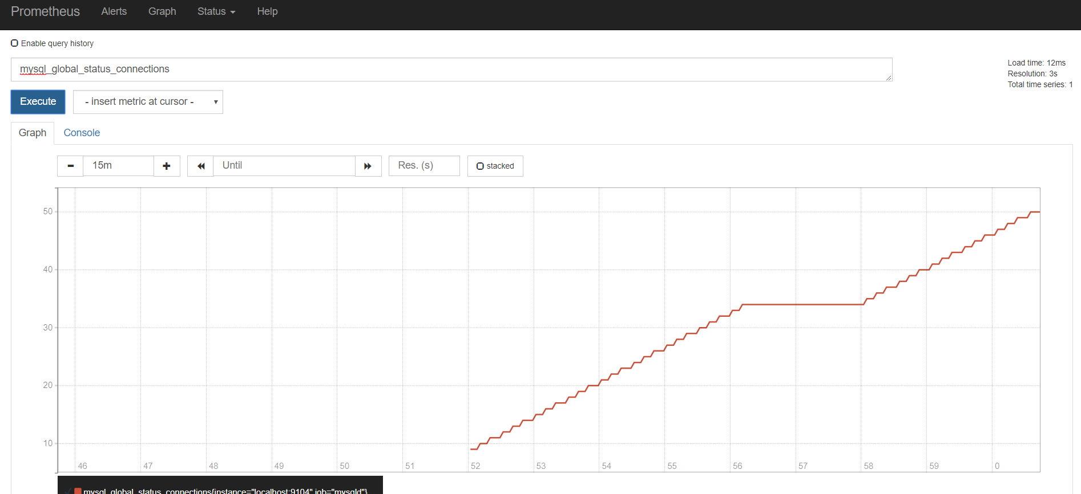

It seems that all these connections are created for the MySQL exporter itself. Some tuning may be in order.

On the command line in the VM, stop the Docker container with the MySQL Exporter.

docker stop mysql-exporter

Now check on the targets page in the Prometheus UI:

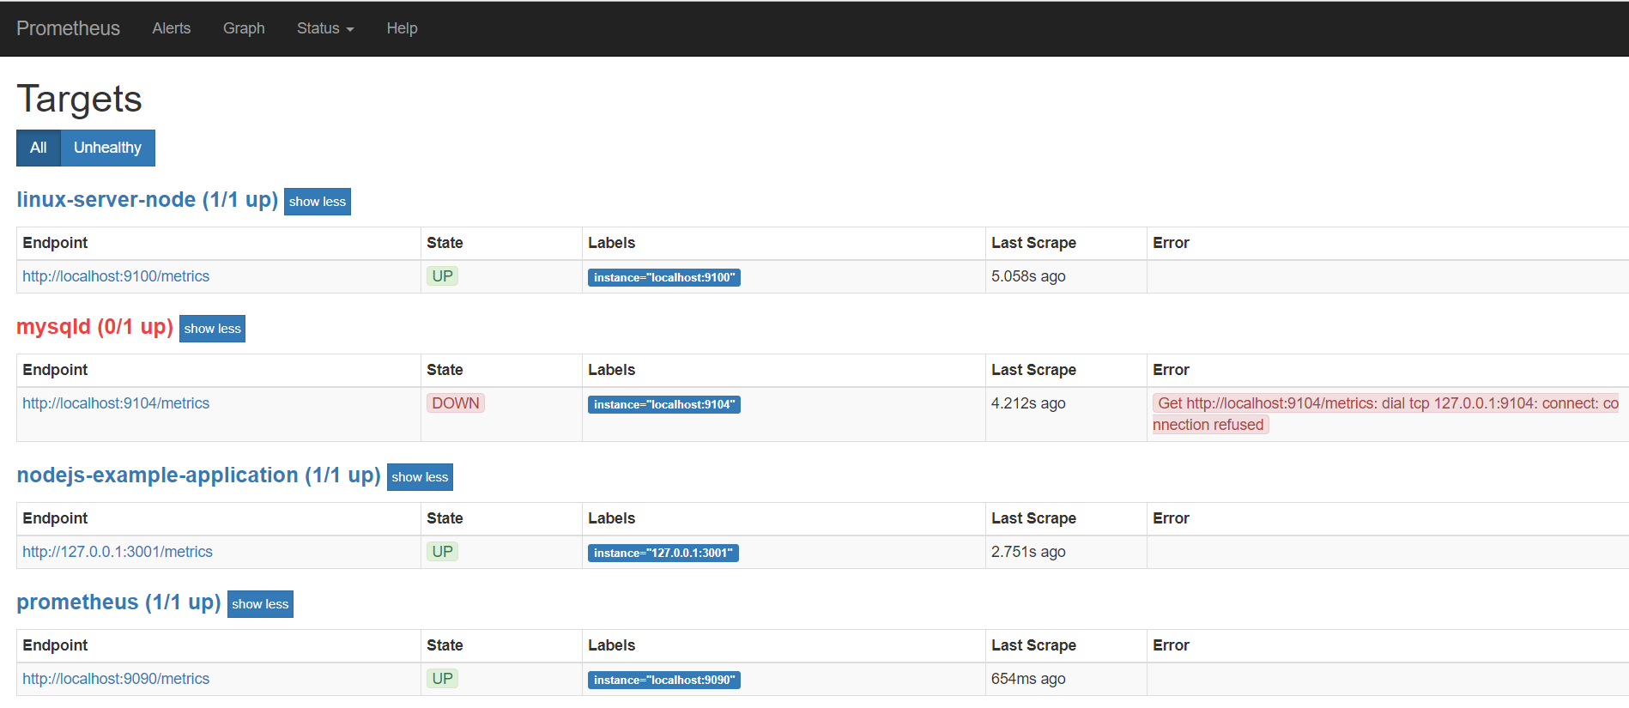

It should be obvious that the MySQL target is no longer available.

When you check under Alerts, you will find no alerts – because none have been configured yet.

# Application Specific metrics from a NodeJS application

Prometheus can be used to monitor any metric – produced by any type of component. Infrastructure components – such as Linux servers – and platform components such as Databases and Messaging Systems – are commonly monitored. Even more important is monitoring business applications for the aspects that really matter to end users. For that to happen, metrics that are indicative of those aspects should be exposed by the business applications.

Developers creating business applications should make sure that meaningful, functional metrics are exposed by their application. Generic exporters generally not be able to extract metrics that translate directly into meaningful business indicators. Prometheus Client Libraries are available for all prominent programming languages. Using such libraries, it becomes straightforward to add metric exposing capabilities to an application. Note: defining what those metrics should be is still the responsibility of the DevOps team.

We will now take a look at a simple Node JS application that has been instrumented: it exposes application specific metrics that are deemed relevant for observing application behaviour. Additionally, the client libraries expose generic metrics for their specific runtime technology stack.

First you need to install Node JS – if it is not already set up in your VM (you can check this by executing “node --version"). To install Node JS, execute

sudo apt install nodejs

Answer *yes* when asked ‘Do you want to continue?’ during the package installation.

Do the same for NPM:

sudo apt install npm

Note: this will take considerable time, probably several minutes.

If you now execute

node --version

you should get the version label for he the installed version of the Node JS runtime.

And with

npm --version

you should get the version label for he the installed version of the NPM runtime.

From the command line, navigate to the user’s home directory.

cd ~

Then clone a GitHub repo:

git clone https://github.com/RisingStack/example-prometheus-nodejs

This will copy the sources of an instrumented NodeJS application to the VM.

Navigate into the directory *example-prometheus-nodejs* and execute

npm install

to install the library dependencies for this application.

Inspect the source code of the Node application at this URL: <https://github.com/RisingStack/example-prometheus-nodejs/blob/master/src/server.js> . You will see how the /metrics endpoint is exposed and how GET requests are handled by Prometheus.register.metrics(). This generic function returns the proper Prometheus format – and injects all generic NodeJS metrics as well as all application specific metrics: *checkoutsTotal* and *httpRequestDurationMicroseconds*.

Run the NodeJS application using

nohup npm start &

You can now access the NodeJS application at [http://192.168.188.112:3001/](http://192.168.188.111:3001/) and invoke its most special functionality at: [http://192.168.188.112:3001/checkout](http://192.168.188.111:3001/checkout) .

The Prometheus metrics exposed by the application – through the use of the NodeJS Client Library - can be read at: [http://192.168.188.112:3001/metrics](http://192.168.188.111:3001/metrics). The custom – application specific – metrics can be found at the bottom of the document. See documentation on prom-client - https://www.npmjs.com/package/prom-client - for details on the standard metrics.

In order to make Prometheus scrape the metrics from the NodeJS example application, you should add another scrape-job in the prometheus.yml file:

- job_name: nodejs-example-application

scrape_interval: 5s

static_configs:

- targets:

- 127.0.0.1:3001

Restart the Prometheus server – or: have the configuration file reloaded by sending a  HTTP POST to the */-/reload* endpoint.

Verify if the NodeJS Example application is now added as a target : [http://192.168.188.112:9090/targets](http://192.168.188.111:9090/targets)

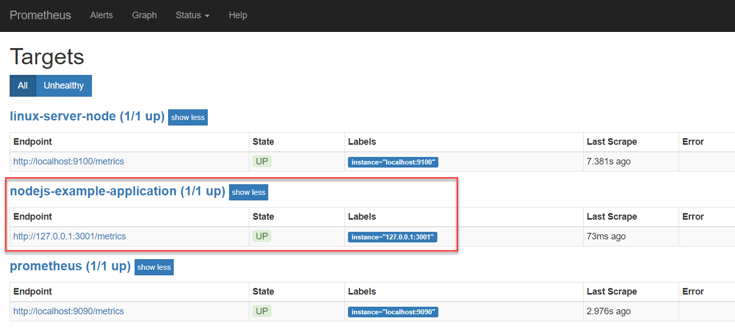

Go to the graph tab. Type *check* in the input field. The auto suggest option should now list *checkouts_total* as a metric available for inspection. This is one of the two custom metrics defined in the NodeJS application, through the Prometheus Client Application for NodeJS .

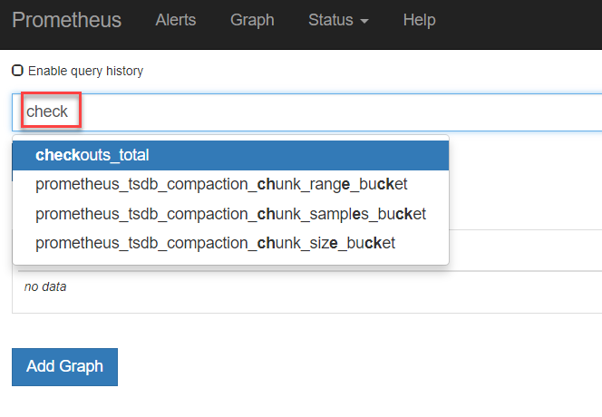

Select checkouts_total and press the Execute button:

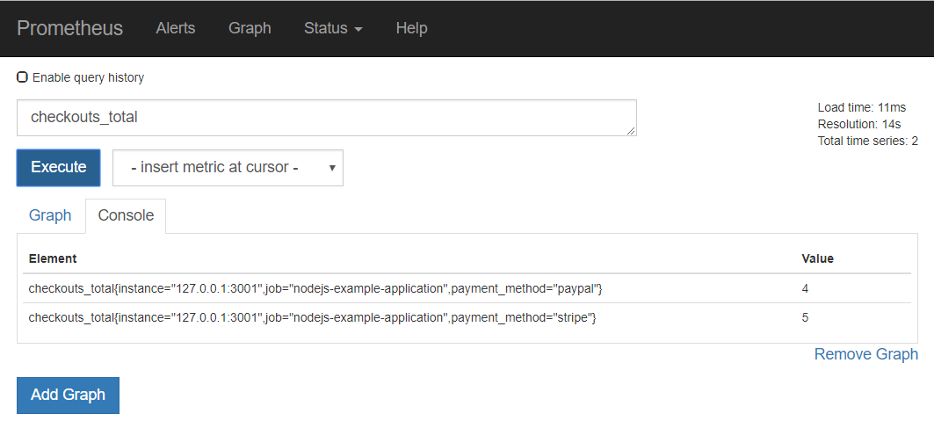

Make a few more calls to [http://192.168.188.112:3001/checkout](http://192.168.188.111:3001/checkout) .

Press Execute again in the Graph tab of the Prometheus console. The values for the *checkout_totals* metric for each of the *payment_method* dimension values are probably updated.

Switch to the Graph tab to a visual representation of the metric over time:

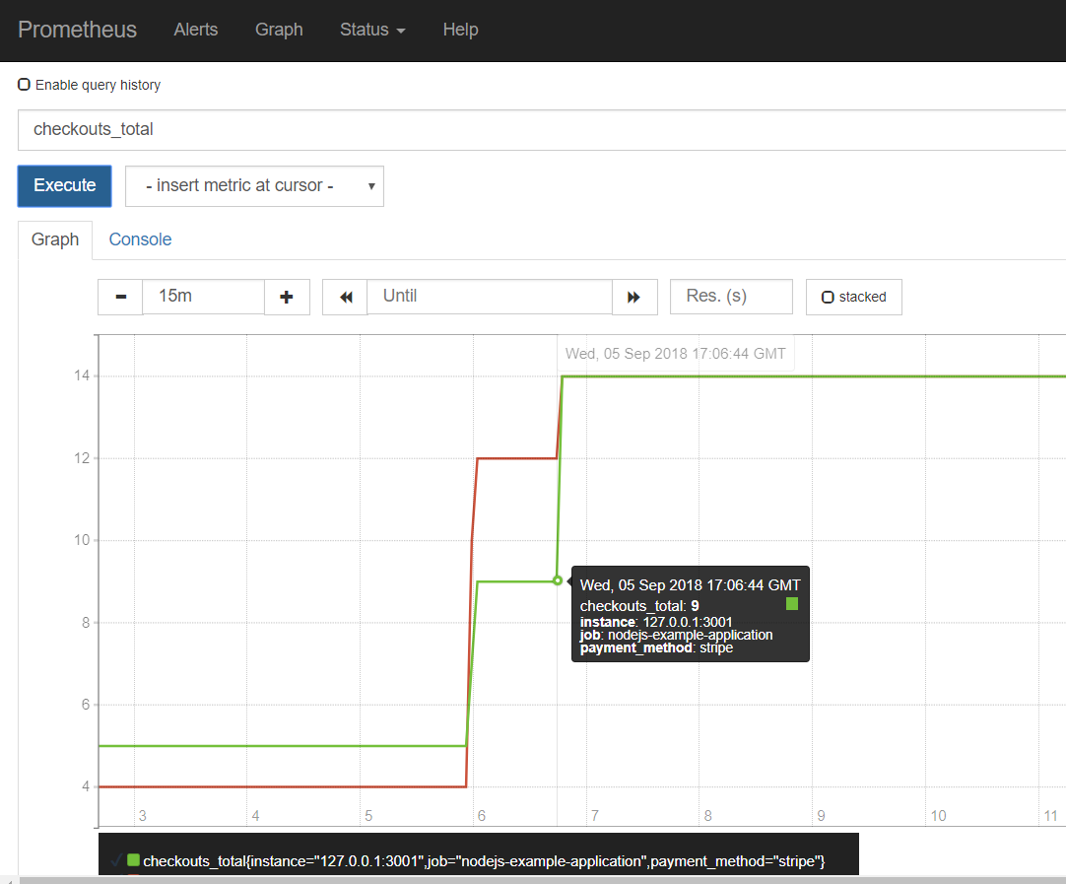

Another custom metric defined by the Node JS Example application is *http_request_duration_ms*. This metric is available as bucket, count and sum

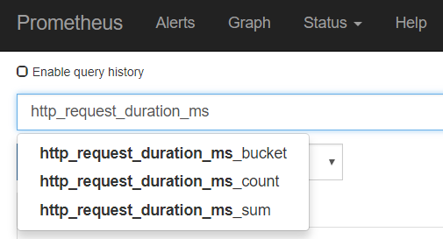

Select the *http_request_duration_ms_bucket* entry and press Execute. On the Console tab, you will get an overview for each of the predefined buckets (each one specifying a certain duration in microseconds of handling the request) how many requests were in that bucket (or in a lower one). In the example, 16 requests were handled within 0.1 milisecond and 27 were handled within 5 ms.

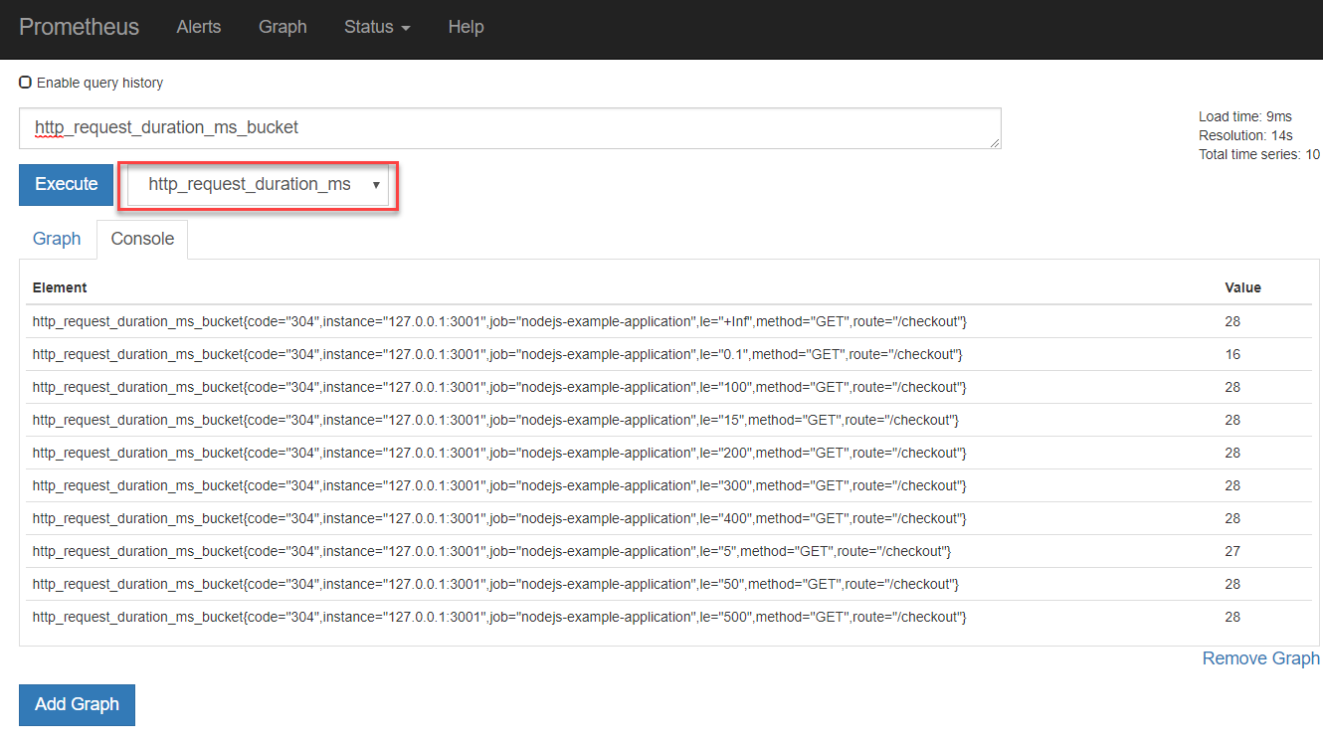

Note: the value for this Histogram metric is set in the server.js file in lines 63 through 71.

# Alerts

There are two parts to alerting. First, adding alerting rules to Prometheus, defining the logic of what constitutes an alert. Secondly, configuring the Alertmanager to convert firing alerts into notifications, such as emails, pages, and chat messages.

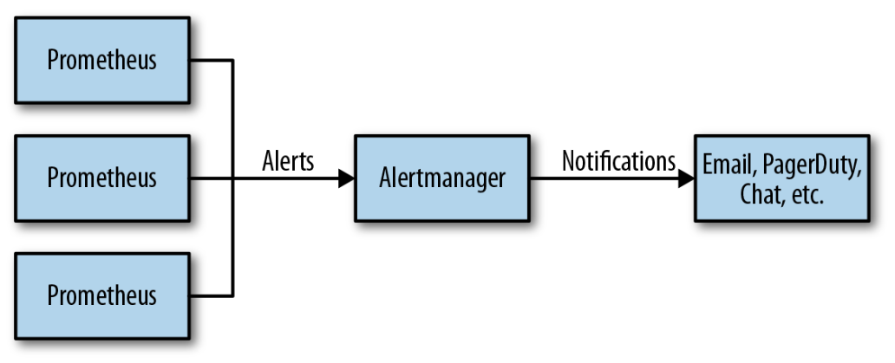

## Configure Alert Rules on Prometheus

Alert Rules can be configured in yml files that are referenced from prometheus.yml. In the home directory for Prometheus, create a new file called rules.yml:

cd ~ /prometheus-2.3.2.linux-amd64

vi rules.yml

and enter the following content into this new file:

groups:

- name: target_rules

rules:

- alert: InstanceDown

expr: up == 0

for: 1m

Save the change.

This configures an alert called InstanceDown that should fire if the metric *up* – which for each scrape job indicates of the corresponding target is available – equals 0 and does so for at least 1 minute. This condition is true if the target is not available.

Stop Prometheus if it is running.

Edit prometheus.yml:

vi prometheus.yml

and type

- "rules.yml"

under “rule_files:” . Save the change.

Start Prometheus again.

If you now check under Alerts in the Prometheus console, you should find one alert active – because the MySQL target can still not be scraped:

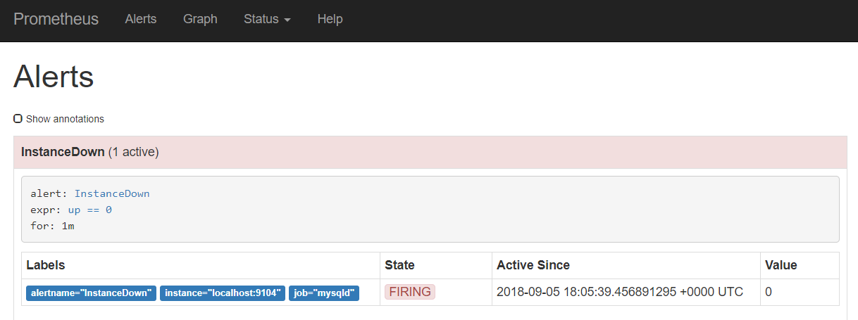

The InstanceDown alert – which is automatically configured – is firing because one of the target instances has been down for at least one minute.

No notification is sent and no automatic remediation is performed. This alert will continue to fire until the MySQL Exporter is back on line – or the Prometheus configuration has been changed.

## Define a Business Alert Rule

Alerts can be defined on any metric – to watch out for technical conditions, related to infrastructure and platform errors, or to guard business conditions. We will look at a more functional, business oriented alert now – although the example is somewhat farfetched.

Define the following entry in the rules.yml file under the groups entry:

- name: my_custom_rules

rules:

- alert: CheckOutsOdd

expr: checkouts_total{job="nodejs-example-application"} % 2 == 1

Here we specify that an alert should be fired if the *checkouts_total* metric – exposed by the example Node JS application - has an odd (not even) value.

After saving this change to rule.yml, restart the Prometheus server. Check in the Status | Rules page if the new custom rule is loaded correctly.

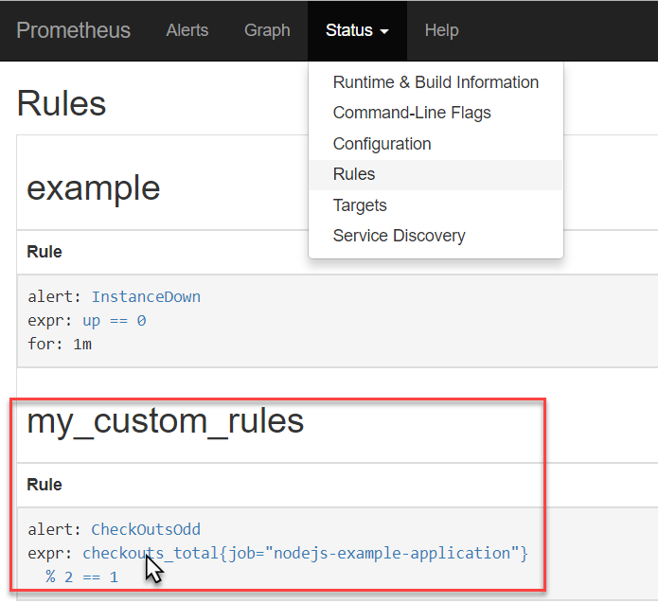

Now you can check the current values for the checkouts_total metric (note: there is one value for each payment type) in the Prometheus UI:

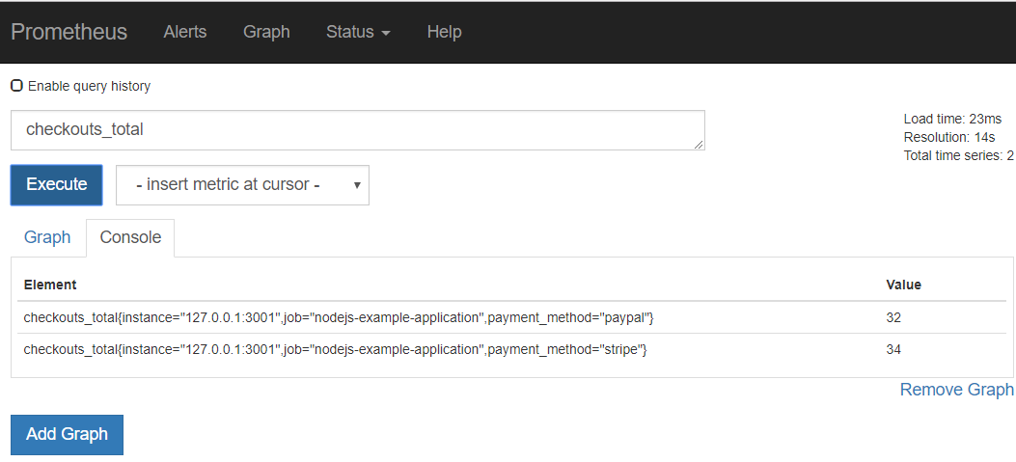

In the Alerts tab, you can check if the *CheckOutsOdd* alert is firing:

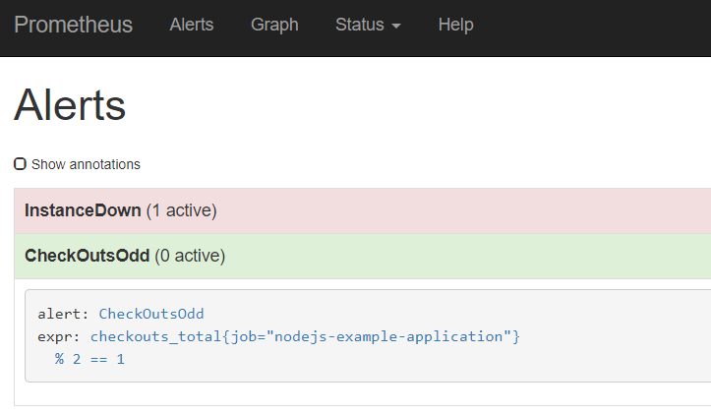

If it is not firing, make one or two requests to [http://192.168.188.112:3001/checkout](http://192.168.188.111:3001/checkout) . Before too long, the alert will fire – or will stop firing.

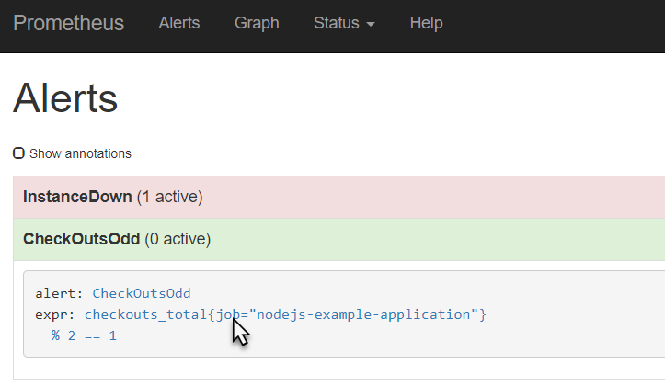

Note: The expression used in the rules.yml entry can also be tested in PromQL field in the web ui, , simply by clicking on the expression in the alert rule:

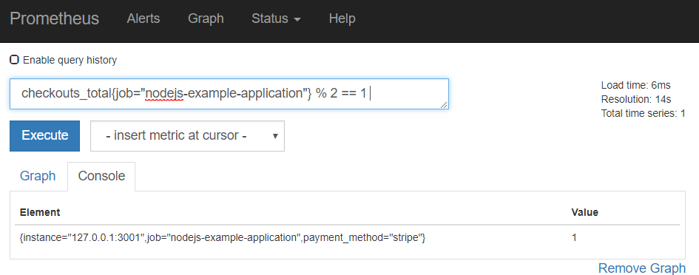

### Optional: Add Annotations to Alerts

The Alert definition in the rules file can be further enhanced with labels and annotations. Labels can be used later on for routing alerts and annotations provided human-oriented context for an alert. Labels are for example used to indicate the severity of an alert, its business domain or to suggest the team or specialism required to investigate.

Edit the rules.yml file and extend the alert node with:

labels:

severity : purple

service: finance

Annotations provide context that are available to human staff. They consist of a combination of static text and dynamically evaluated expressions. The expression $value can be used to include the value of the alert expression in an annotation and the expression $labels returns an map with the labels from which an individual label can be retrieved like this: {{$labels.job}}.

Specify annotations for the CheckOutsOdd alert like this:

annotations:

descriptions: 'The number of checkouts is odd for payment method {{$labels.payment_method}} . This has been recognized as a business oddity that deserves notification'

summary: 'Odd number of Checkouts for payment method {{$labels.payment_method}}'

Restart Prometheus.

When the alert conditions are satisfied, you will find the values for the newly defined labels as well as the annotation in the Alert page of the Prometheus console:

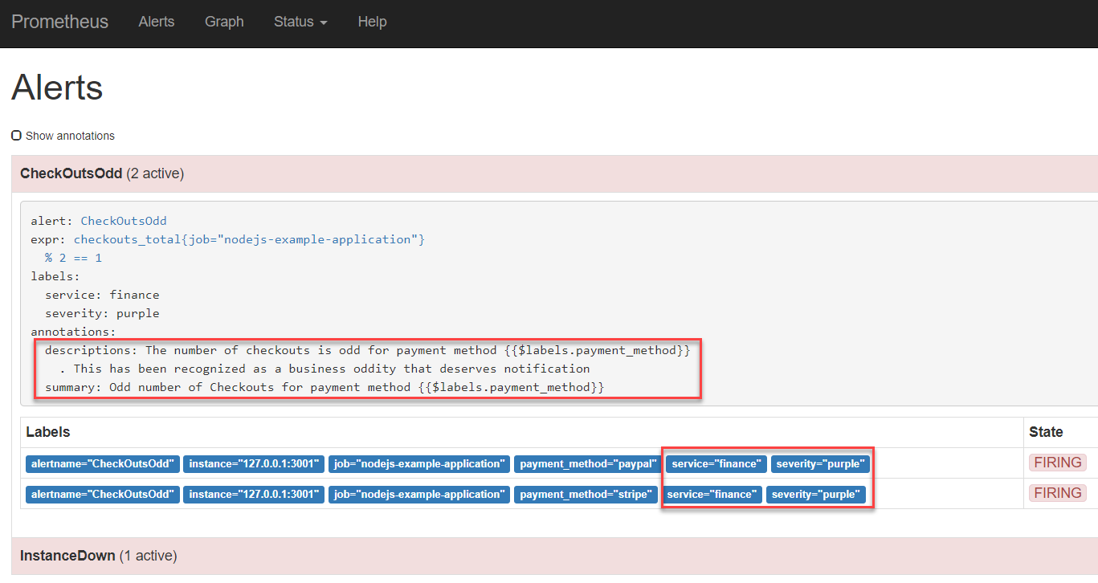

In a little while, you will see the actual values of the annotations in the Alertmanager – with the expressions resolved.

Documentation: see <https://prometheus.io/docs/prometheus/latest/configuration/alerting_rules/> and <https://petargitnik.github.io/blog/2018/01/04/how-to-write-rules-for-prometheus>

## Turning Alerts into Notifications

The alert manager keeps track of all firing alerts from one or even multiple Prometheus instances. Based on rules setup in the file *alertmanager.yml* in directory ~/alertmanager-0.15.2.linux-amd64, it decides if notifications should be sent and if so where to. Channels for sending notifications include email, PagerDuty, HipChat, Slack, WeChat and Web Hook.

In this section, we will use a Slack channel as our notification target. We will configure the alertmanager to send notifications to a selected channel in a Slack Workspace. We will leverage the ‘Incoming WebHooks’ app in Slack – that takes the HTTP request from the Alert Manager and interprets it as a Slack message.

### Prepare Slack Workspace

You can either create and/or configure your own Slack Worksapce or make use of a predefined one.

#### Your own Slack Workspace

Create your own new Slack Workspace – through <https://slack.com/create> .

Follow the instructions to create and log in to your own new workspace.

Create the channel into which Alert notifications should be sent – this can also be the general channel.

When done, add the “Incoming WebHooks App” from App Directory to your workspace.

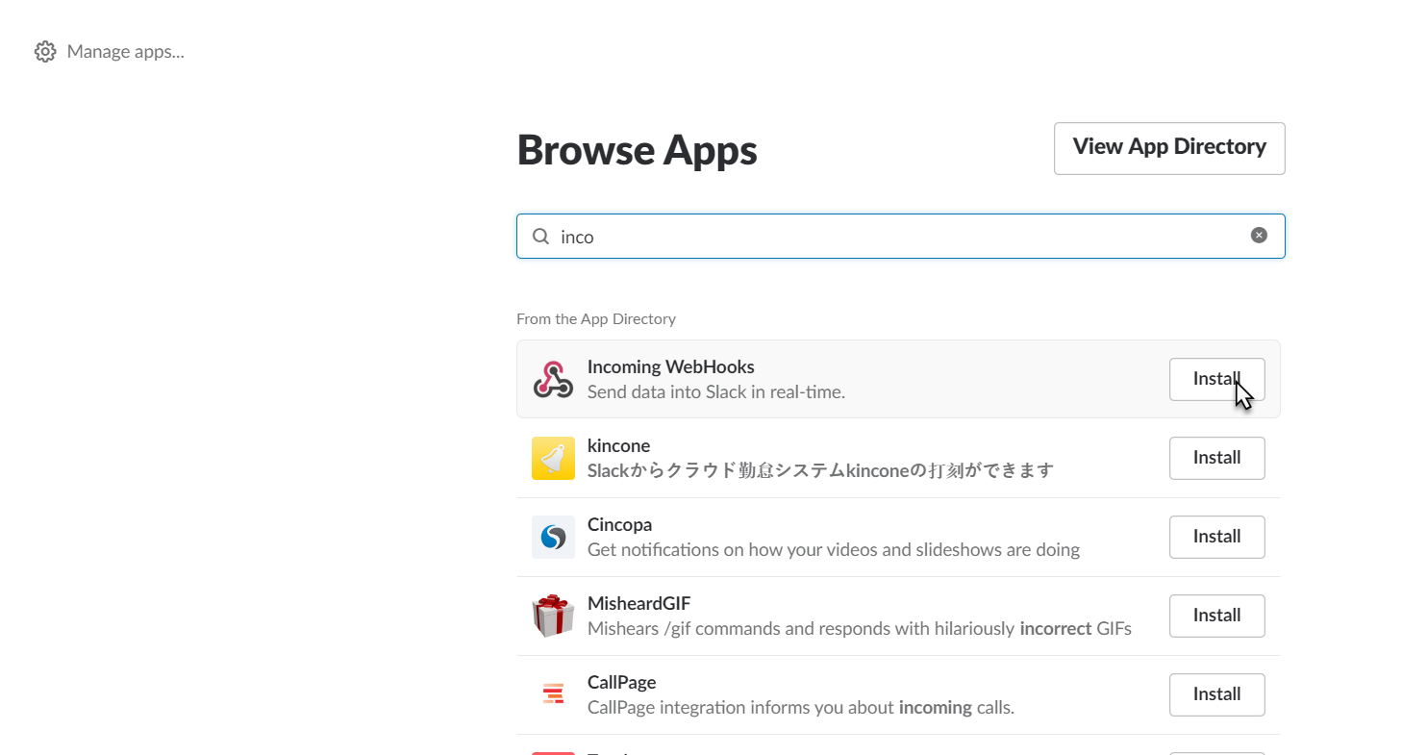

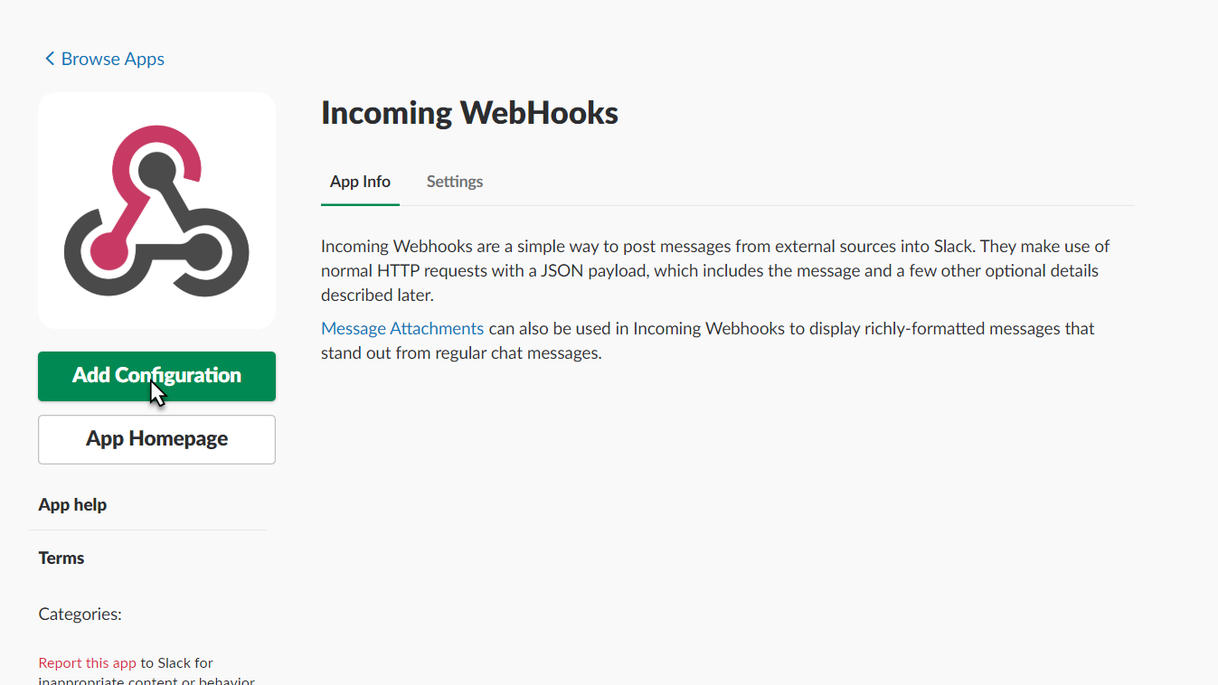

Configure the Incoming WebHooks app for the specific channel:

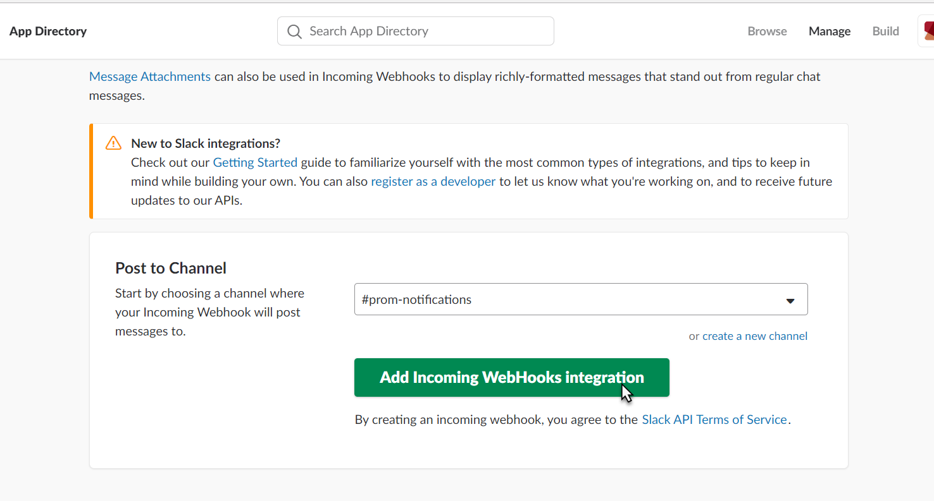And click on ‘Add Incoming WebHooks integration’.

Get the WebHook URL

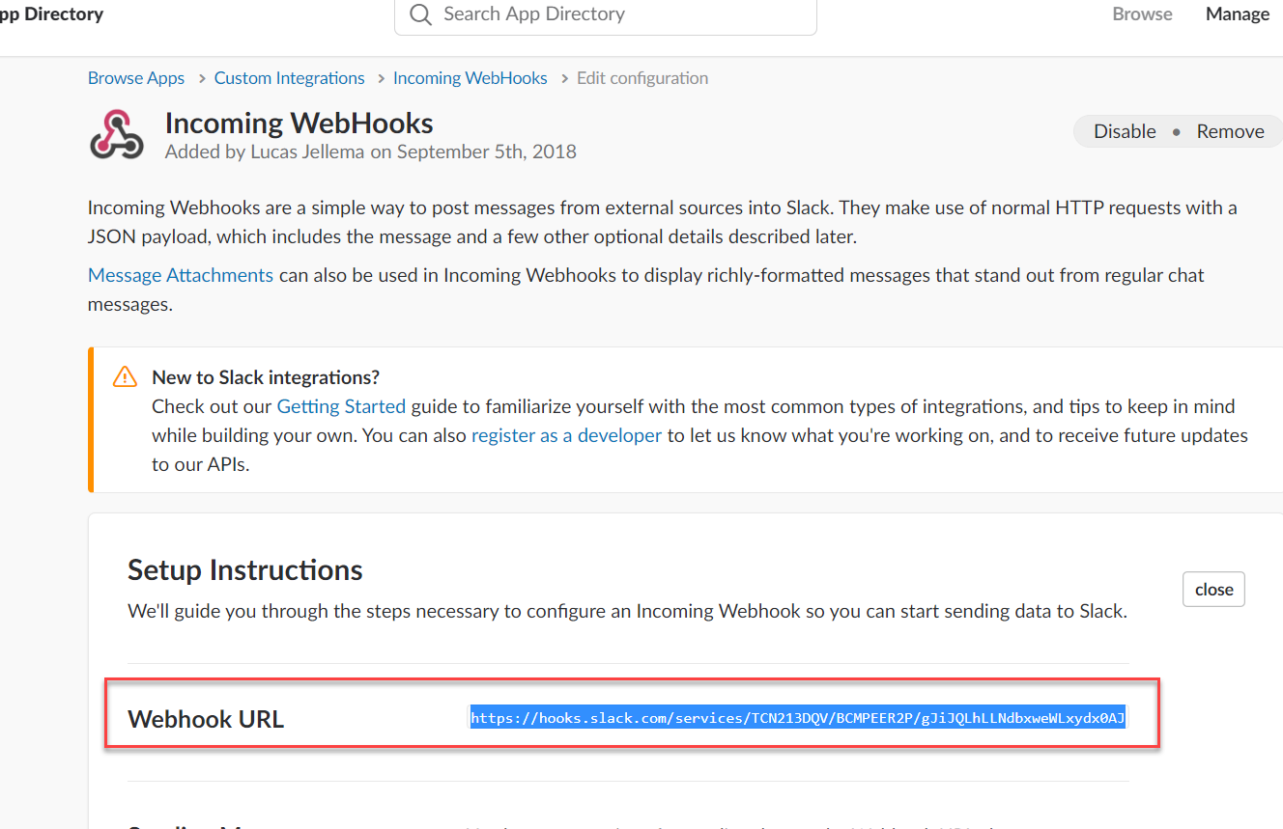

We will configure this URL in the alert manager’s configuration.

#### Leverage a Predefined Workspace

Open this URL in your browser: <https://amis-prometheus.slack.com> . Sign in with credentials [lucasjellema@gmail.com](mailto:lucasjellema@gmail.com) and password 123321.

Click on Apps in the lower left hand corner.

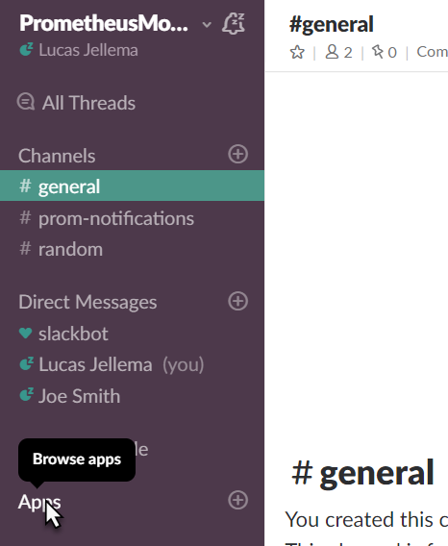

Click on View for the incoming-webhook app:

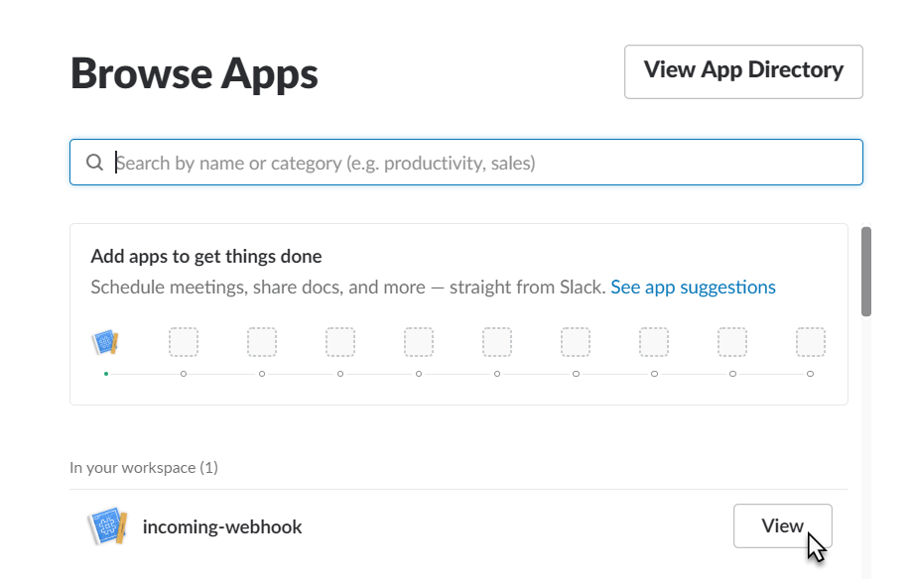

Click on Settings for the app to inspect the details:

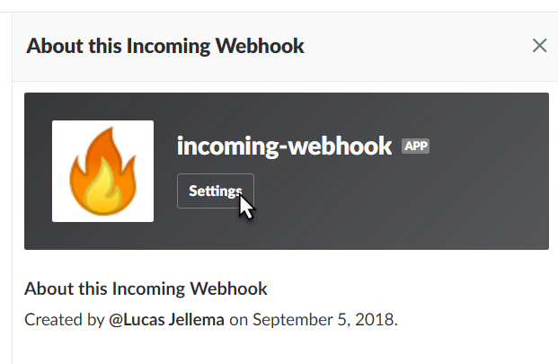

And when the app details are shown:

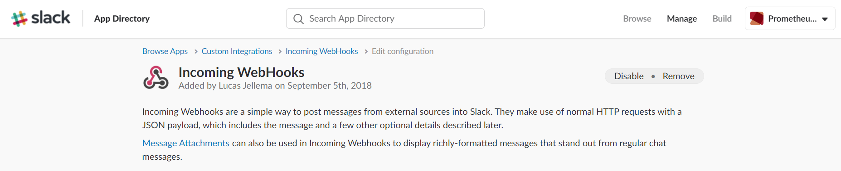

Scroll down to locate the webhook url:

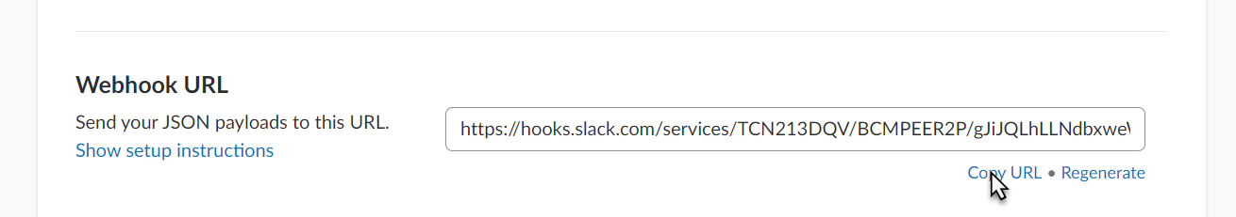

And copy this URL. You need it to configure the (Prometheus) Alert Manager.

### Configure Alert Manager to Send Notifications to Slack

Navigate to directory ~/alertmanager-0.15.2.linux-amd64/:

cd ~/alertmanager-0.15.2.linux-amd64/

Configure alertmanager.yml

Add this entry under the *receivers* node, just after web.hook:

- name: slack_alerts

slack_configs:

- api_url: <the WebHook URL for Slack>

channel: '#prom-notifications'

Change the value of the *receiver* property under the *route* root node from ‘web.hook’ to ‘slack_alerts’:

route:

group_by: ['alertname']

group_wait: 10s

group_interval: 10s

repeat_interval: 1h

**receiver: 'slack_alerts'**

Start Alertmanager

nohup ./alertmanager &

The Alert Manager also has a Web UI, which is available at: <http://192.168.188.112:9093> .

Test – have an alert raised directly, not from Prometheus:

curl -d '[{"labels": {"alertname": "MySpecialAlertTest"}}]' <http://localhost:9093/api/v1/alerts>

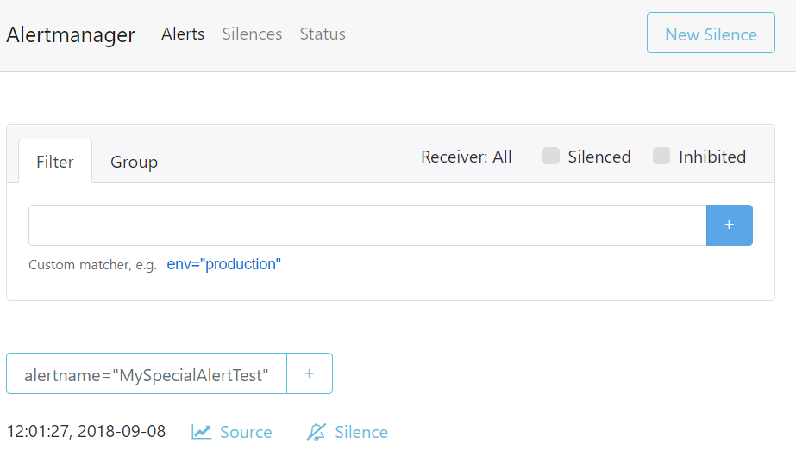

And in Slack:

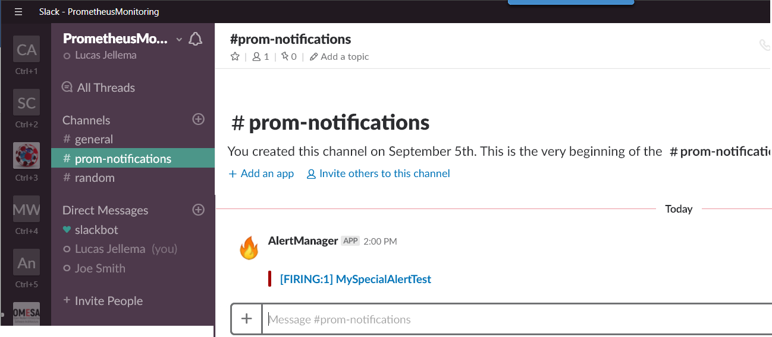

#### Configure Prometheus to Forward Alerts to Alert Manager

Now let’s try to get the alerts identified by Prometheus into the Alert Manager.

Edit prometheus.yml. Configure the locally active Alert Manager in the *alerting* node by specifying the end point 127.0.0.1:9093 as target;

alerting:

alertmanagers:

- static_configs:

- targets:

**- 127.0.0.1:9093**

Save the changes and restart Prometheus.

The Alerts that are visible on the Alerts tab in the Prometheus Console

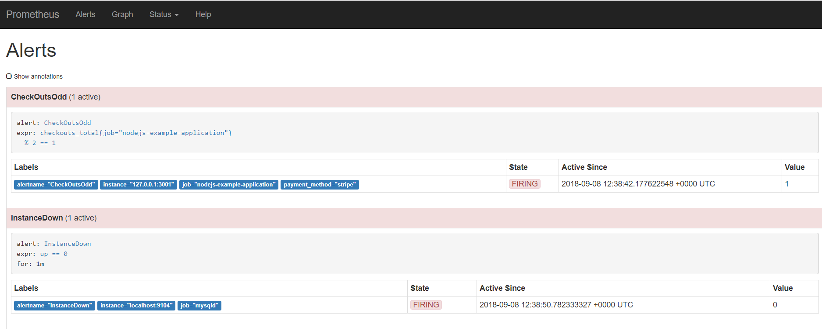

are now also visible in the Web UI of the Alert Manager:

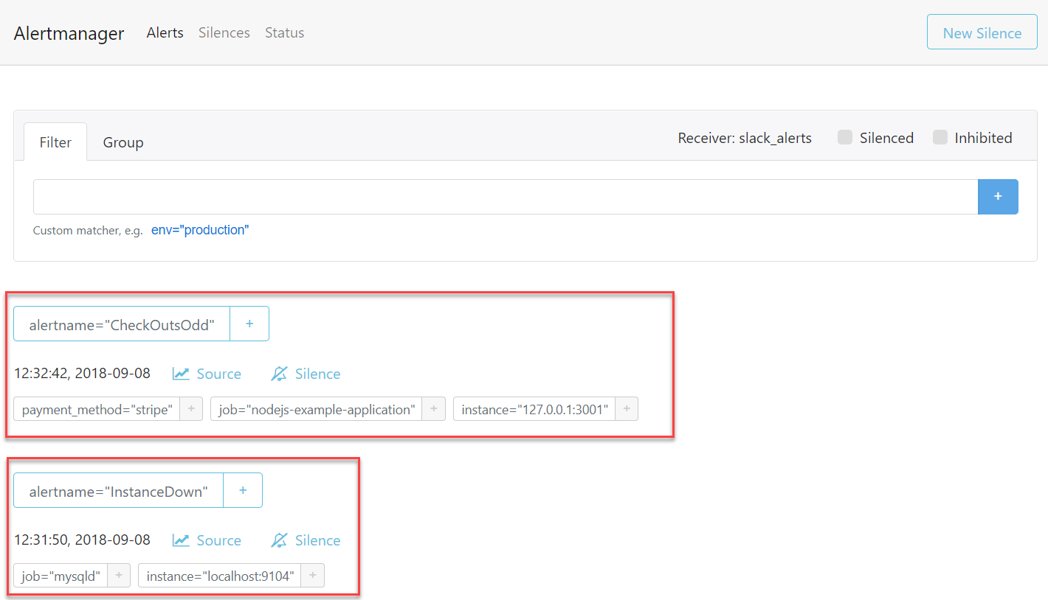

These alerts are sent as notification to the Slack channel, as per the configuration you have just created in the alertmanager.yml file:

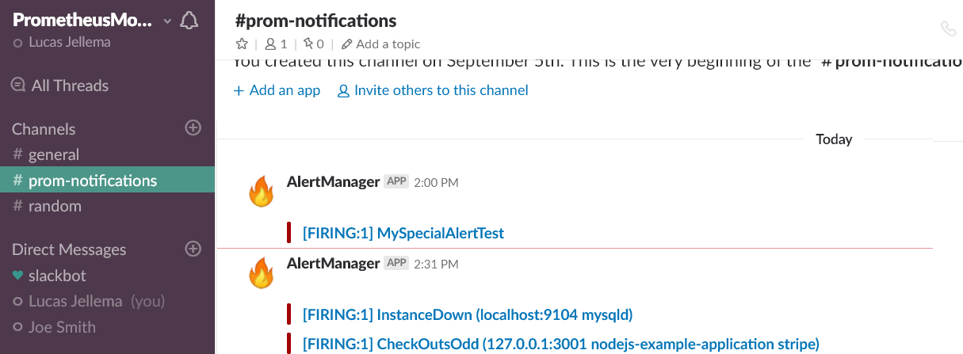

### Optional: Create Pretty Notification Messages using Templates

The notifications in Slack are a little unrefined. Our core technical staff may be fine with this, but some engineers may prefer a little more refined message. That can be done – using notification templates configured for the Alert Manager in alertmanager.yml.

First create a special route for the *CheckOutsOdd* alert in a *routes* node under the *route* root.

routes:

- match:

alertname: CheckOutsOdd

group_by: [ service ]

receiver: businessticket

In this route, we can also add instructions for [more complex] grouping, throttling and repeating notifications.

Then, create a new receiver entry in this same file, called businessticket and defined like this:

- name: businessticket

slack_configs:

- api_url: <Incoming WebHook URL Slack Workspace>

channel: '#prom-notifications'

title: 'Alerts in Service {{ .GroupLabels.service }}'

text: >

{{ .Alerts | len }} alerts:

{{ range .Alerts }}

{{ range .Labels.SortedPairs }}{{ .Name }}={{ .Value }} {{ end }}

Context:

{{ range .Annotations.SortedPairs}}{{ .Name }}:{{ .Value }} {{ end }}

Wiki: http://wiki.mycompany/{{ .Labels.alertname }}

{{ end }}

Note: the blank lines are intentional. Simply using \n did not create the new line characters I was hoping for.

Save the file alertmanager.yml with these changes and restart the alertmanager. This configuration file is reloaded. When next you trigger alerts, the notification shown in Slack will be extended with the information configured in the template:

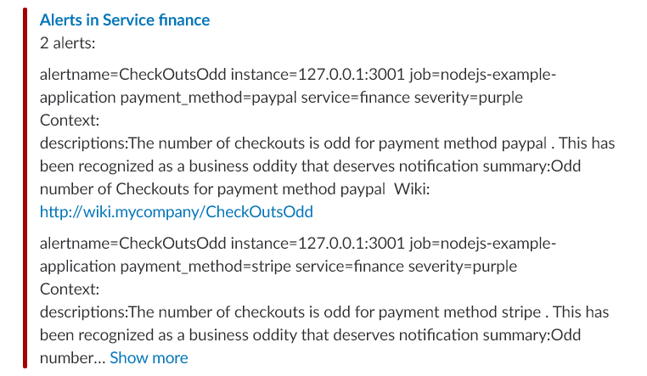

*Resources*

<https://www.robustperception.io/using-slack-with-the-alertmanager>

Documentation on Notification Templates: <https://prometheus.io/docs/alerting/notification_examples/>

# Dashboards with Grafana

A lot of information about the metrics gathered by Prometheus can already be learned from the Prometheus Web UI. The alert rules in combination with the Alert Manager’s capability of translating firing alerts into notifications into virtually any channel allow us to take action when undesirable conditions occur. What then do we need a dashboard for?

A well-designed dashboard – and that is a stiff challenge right there – can support engineers acting on alerts by providing contextual information about the alert itself and the components from which the alert originated and their recent history. The dashboard also provides insight – both for incident analysis as well as for more tactical insight – in trends over time, such as slowly increasing load or decreasing remaining capacity.

A common companion to Prometheus for Dashboarding – although both play with others too – is Grafana. We will now take a quick look on how we can use Grafana to visualize the metrics gathered and preprocessed by Prometheus.

## Get Going with Grafana

Run Grafana in a Docker container using the following command:

docker run -d --name=grafana -p 3000:3000 grafana/grafana:5.2.3

When the container is running – this will take a few minutes because the Grafana Docker Container Images needs to be downloaded - , the Grafana UI can be accessed on your laptop at [http://192.168.188.112:3000](http://192.168.188.111:3000).

Default credentials are: admin/admin.

Note: when logging in for the first time, you are prompted to change the password. In this workshop environment you can safely change to *admin* (so not really change at all).

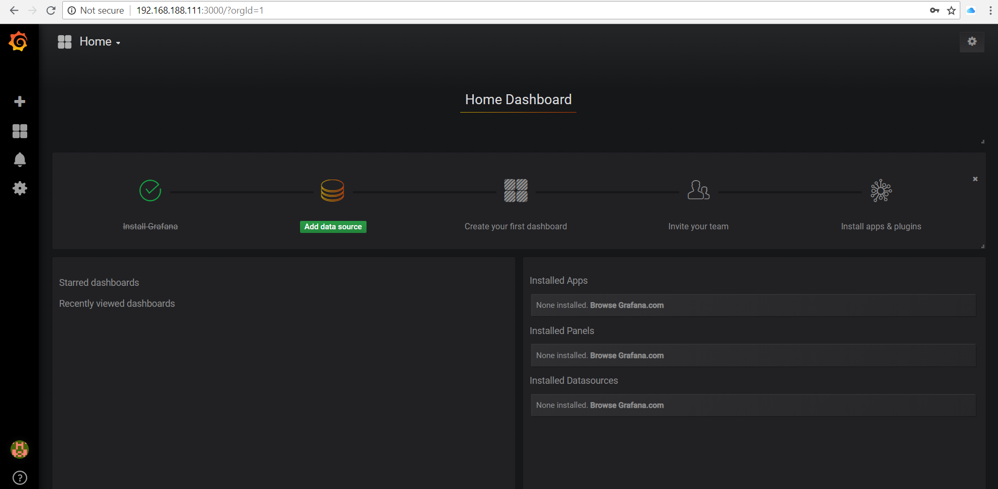

Grafana uses data sources to fetch information used for graphs. There are a variety of types of data sources supported out of the box, including MySQL, CloudWatch, Elastic Search, OpenTSDB, PostgreSQL, and of course, Prometheus. A Grafana dashboard can have graphs from variety of sources, and you can even mix sources in a graph panel.

Let’s now add a Data Source for your Prometheus instance.

Click on Add data source and add a data source with a Name of **Prometheus**, a Type of Prometheus, and a URL of http://192.168.188.112:9090

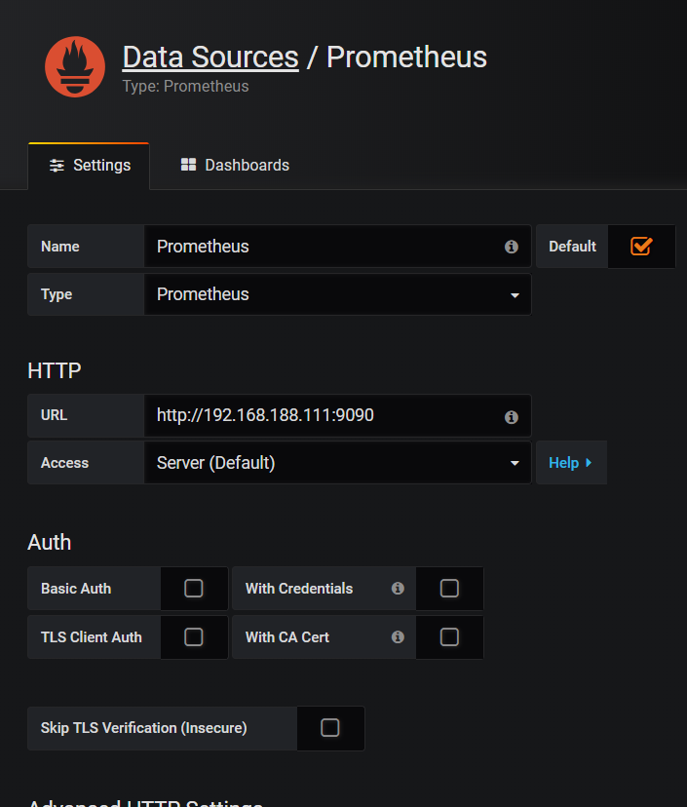

Press Save & Test.

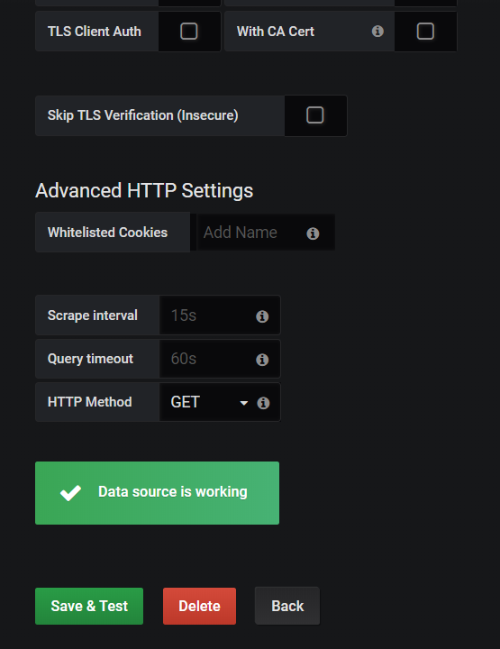

Toggle to the tab *Dashbaords* and click to import the *Prometheus 2.0 Stats* dashboard.

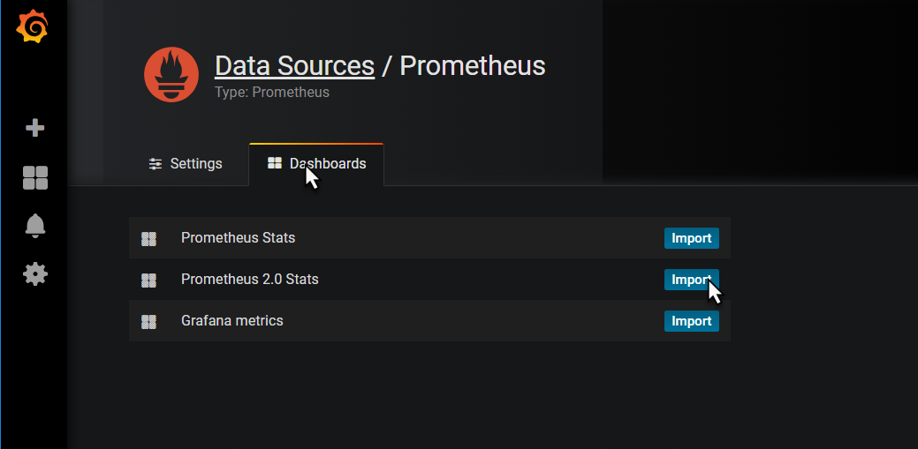

This will import the definition of this dashboard to quickly get us going with a dashboard that displays various metrics on the operational condition of our Prometheus instance, supporting those engineers that have a responsibility for keeping Prometheus in good working order.

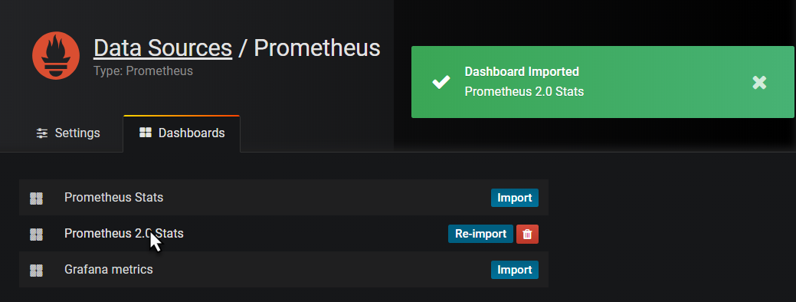

When the dashboard is imported, click on the name of the dashboard – which is a hyperlink to now open the dashboard.

The dashboard appears:

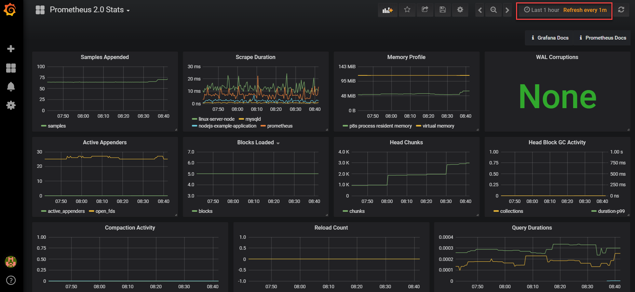

It shows a little of what Grafana is capable of, in terms of visualizing and organizing data. Hover over the graphs with your mouse for example.

Click on the time window widget in the upper right hand corner, to zoom in and out over a time range:

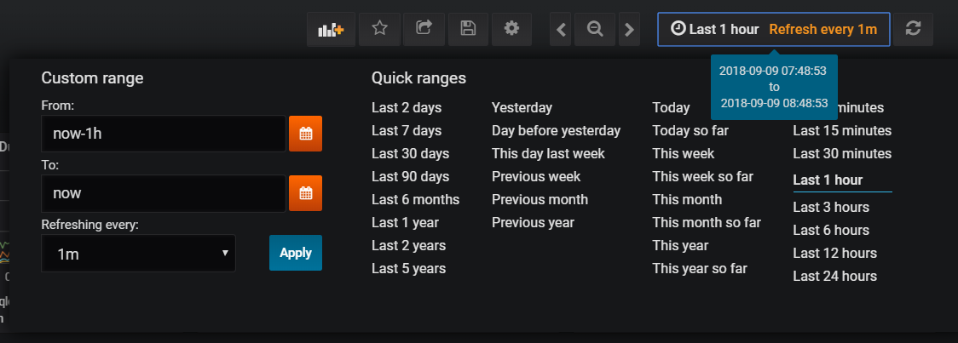

## Creating a New Dashboard

To create your own new dashboard, click on the plus icon in the upper left hand area of the page and select the create a new Dashboard:

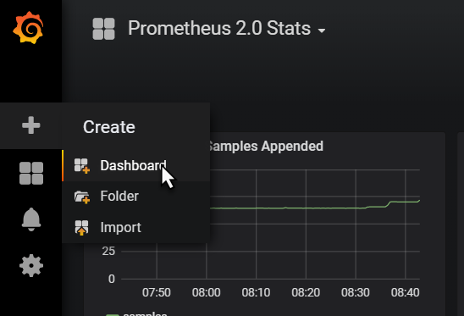

Click on Graph:

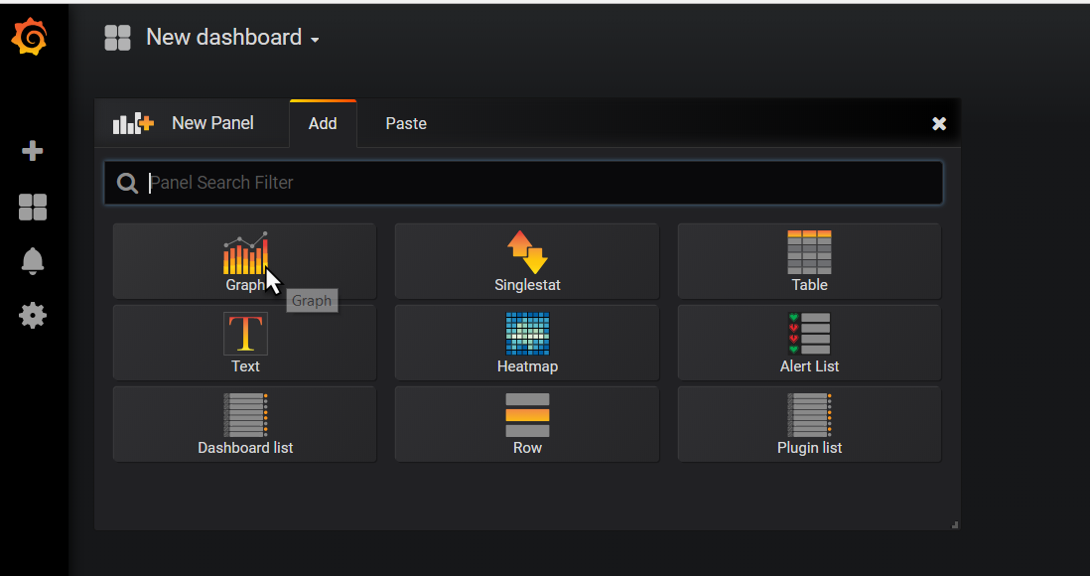

A new Panel with an initial graph appears. Click on Edit in the dropdown menu under Panel Title.

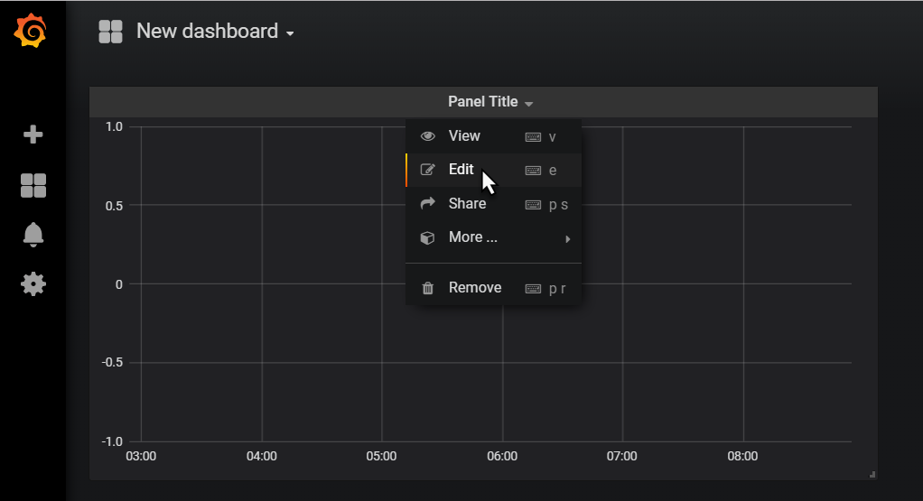

Set the Data Source for the Graph to Prometheus.

Then start typing the name of metric A. Type *check* and that should bring up a list of applicable metrics. Select *checkouts_total*.

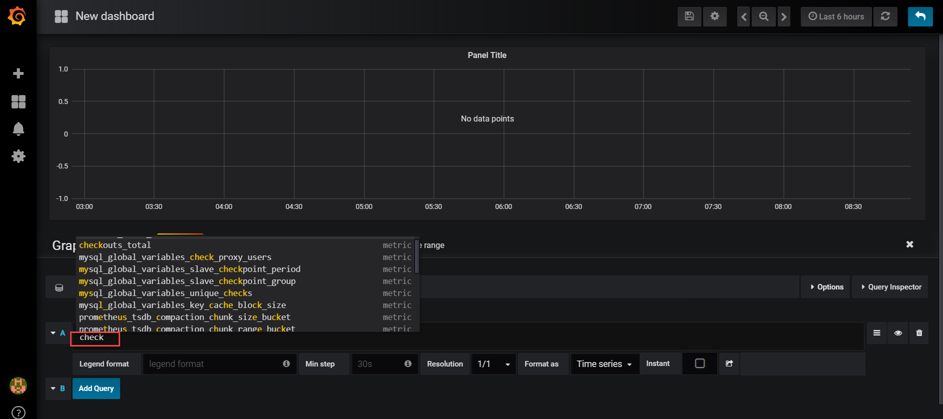

The graph will start to show.

Switch to the General tab and update the title of the graph, for example to Checkout Total (per payment type):

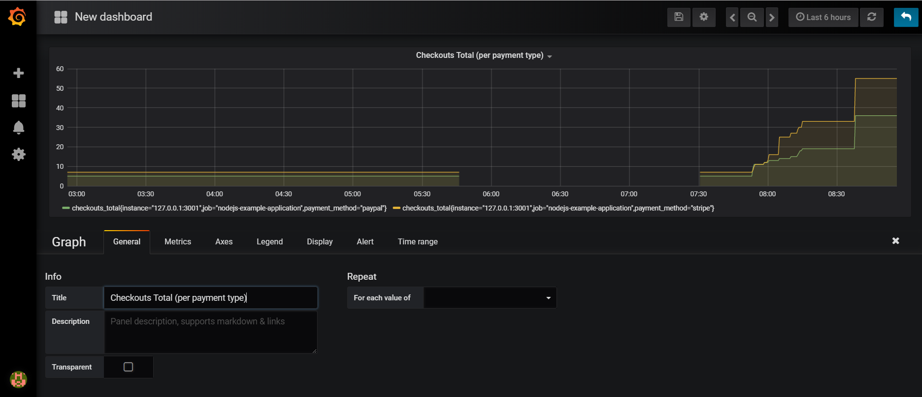

Click on the save icon to save the current state of the dashboard.

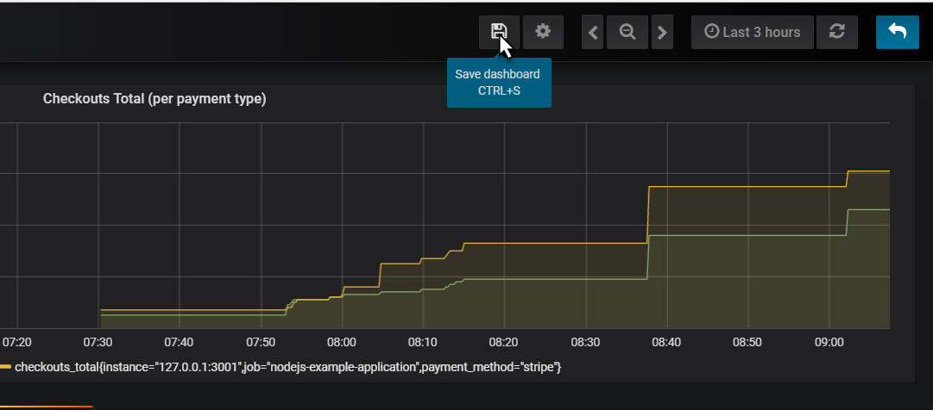

Provide a name for your dashboard

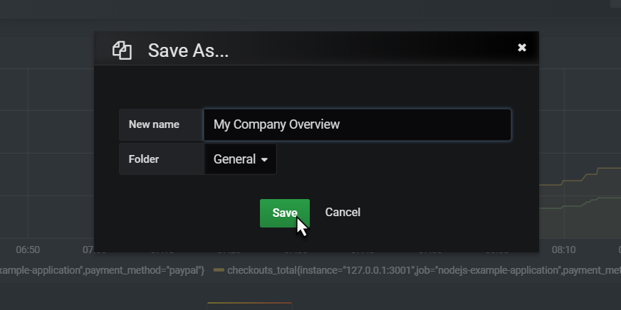

And click on Save.

You now may want to make some calls to <http://192.168.188.112:3001/checkout> to influence the checkouts_total metric that this dashboard is proudly visualizing. If you do so, this should result in a visible step in the chart. So because of a user action in a business application, and because that business application publishes Prometheus metrics, and because Prometheus periodically scrapes and process and stores those metrics and because Grafana periodically collects those stored data and visualizes them, we with our Ops engineer hat on are aware of that activity. And could respond to it.

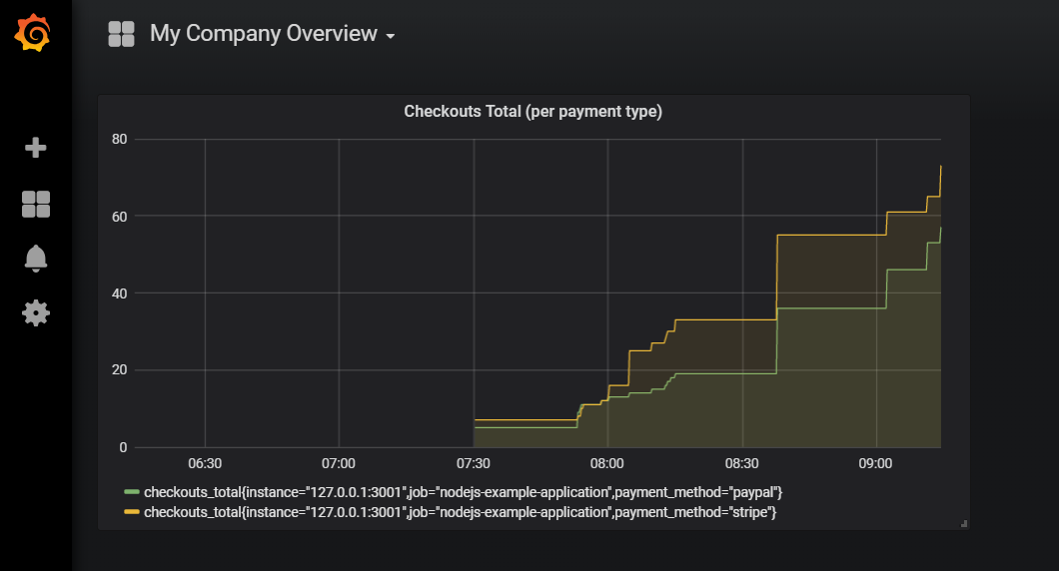

## Extend the Dashboard

Adding additional metrics in a graph is dead easy. They can come from the same or a different data source and they can be related or totally unrelated. And they can also be calculated using the expression engine in Grafana.

### Add Sum of Checkout Totals [over all payment methds]

Click on the panel title for the graph. Click on *edit* in the dropdown menu:

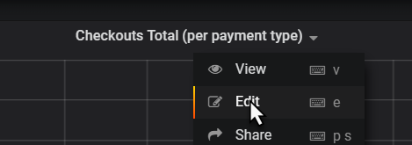

Switch to the metrics tab and click on *Add Query*

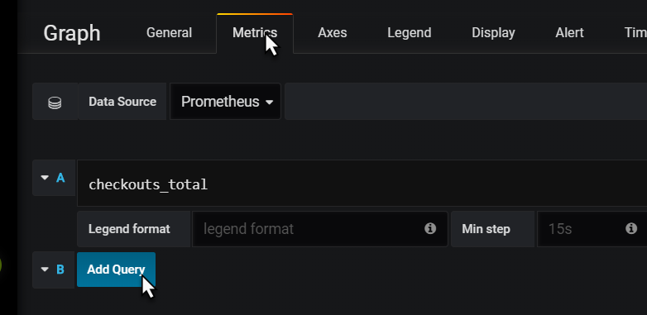

Type sum(ch and select checkouts_total from the suggestion list:

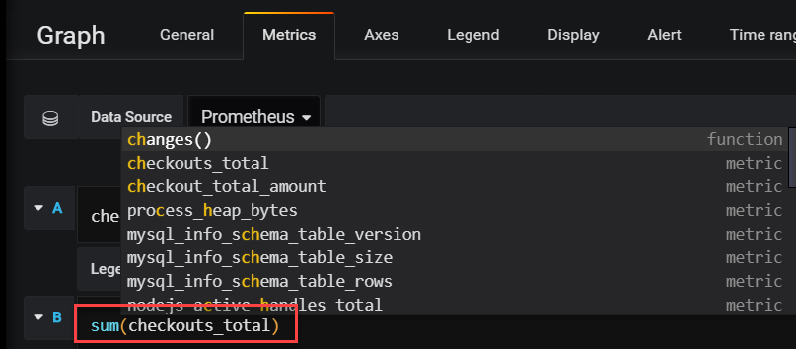

When you tab out of the field, the graph is immediately updated. It now shows the sum over all checkouts_total values:

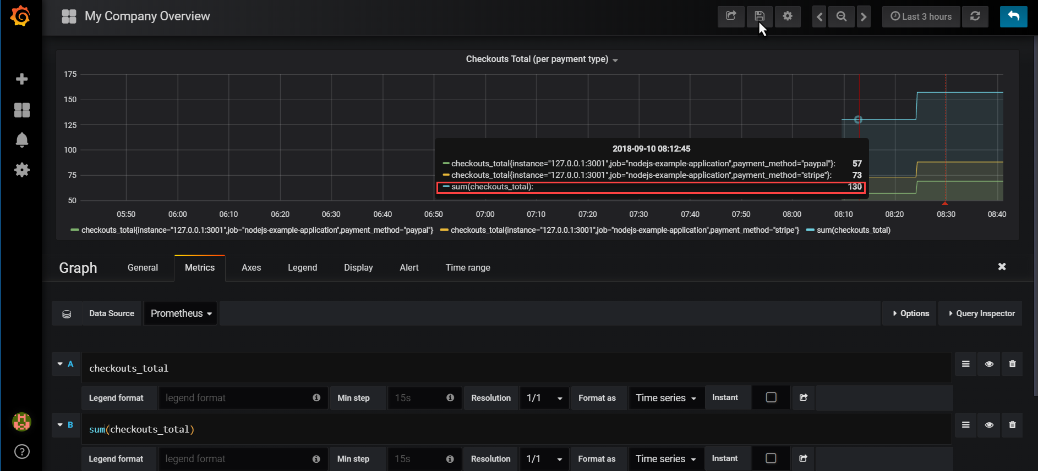

Click on the Save icon to save the updated dashboard definition.

### Add Panel to Show Current Value of Total of Checkout Totals

Grafana panels can be crated for displaying one single value that needs to be highlighted.

As a quick example:

Add a panel, of type Single Stat.

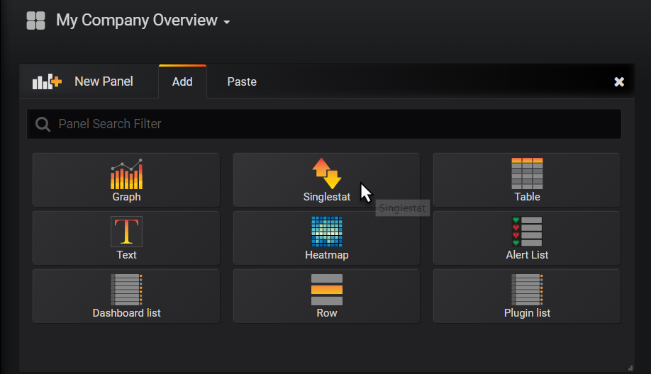

Click on Panel Title | Edit.

Switch to Metrics tab. Type

sum(checkouts_total)

Switch to *Time Range* tab. Set *override relative time* to 1m – to get only the most recent value for the sum.

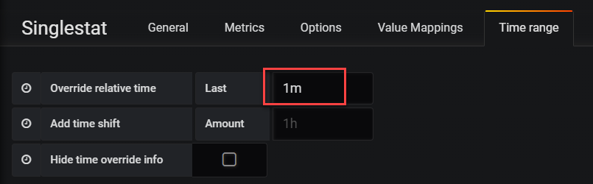

Switch to tab General and set a more meaningful title for the panel.

Save your changes and return to the dashboard.

Finally resize this panel to a more proper size.

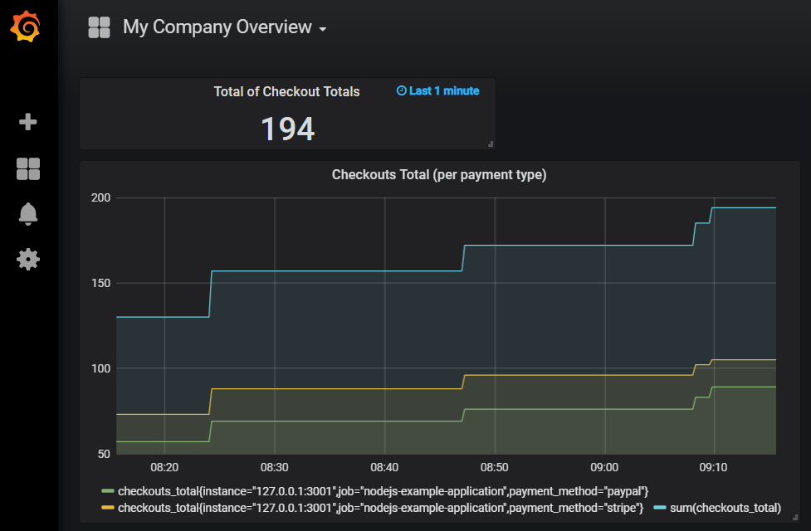

Note: in the Single Stat panel editor is the Options tab where you can define display options – for example to associate specials colors with values or value ranges. In the Value Mappings tab, you can define labels that should be displayed for specific value ranges – for example labels such as *low, medium, high* or *relax, watch out* and *go crazy*.

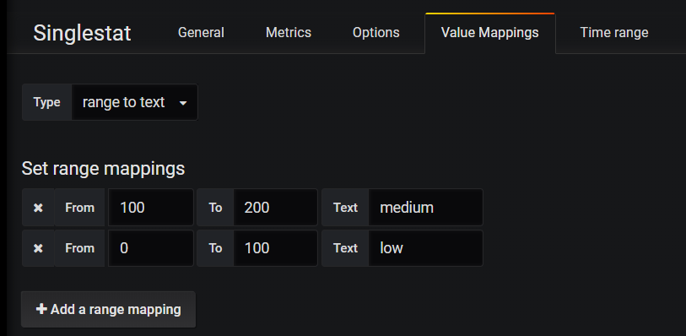

## Using the Alert Mechanism in Grafana

Grafana contains an alert mechanism, somewhat similar to that in Prometheus. There is no direct connection to the Alertmanager or the Alert rules in Prometheus.

Alerts can be defined on panels. Click on the panel title for the checkout totals chart and open the panel editor.

Click on the Alert tab. Then click on Create Alert.

Define a name – for example *Checkouts Total Surprisingly High alert*. Then specify the alert condition – for example:

WHEN sum() OF query(A,1m,now) IS ABOVE 25

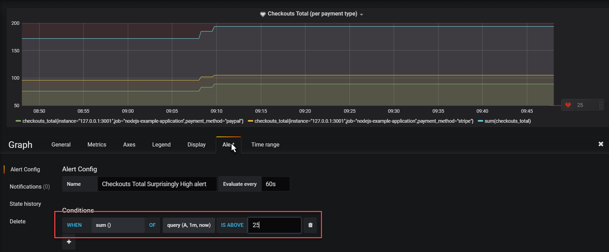

When you scroll down a little, you will find the Test Rule button. When you press this button, the rule is evaluated and info is shown:

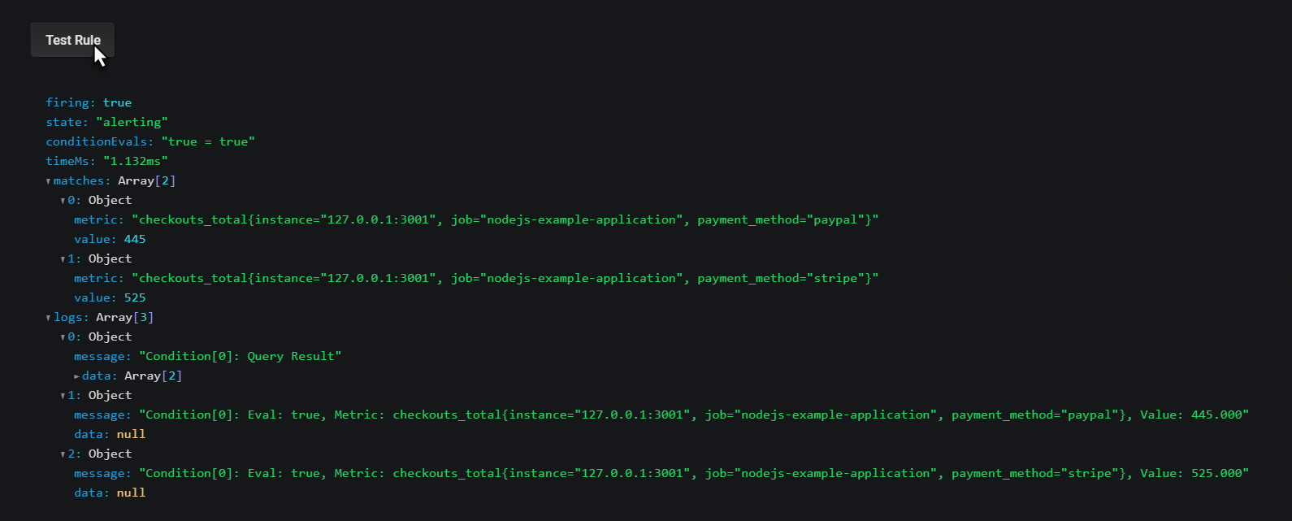

Save your changes and return to the dashboard.

A little icon is shown on the Panel title to indicate that alerts have been defined for this panel.

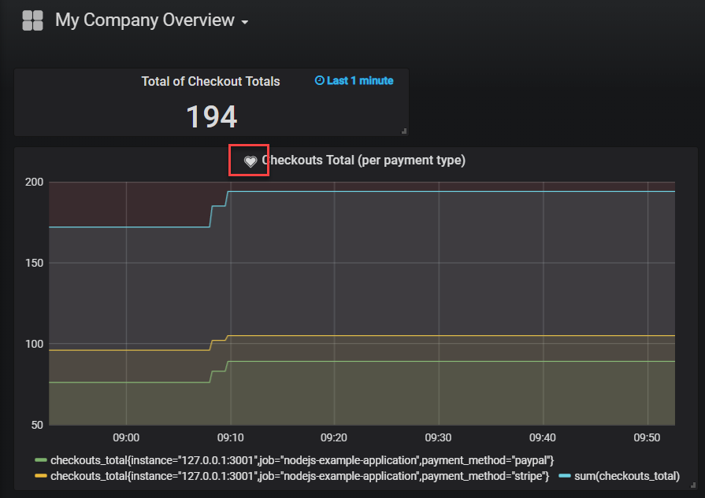

When the alert is active, the heart icon will turn red.

There are several ways to inspect a firing alert:

* drill down to the Panel editor
* check the Alert Rules option from the main dashboard menu  
  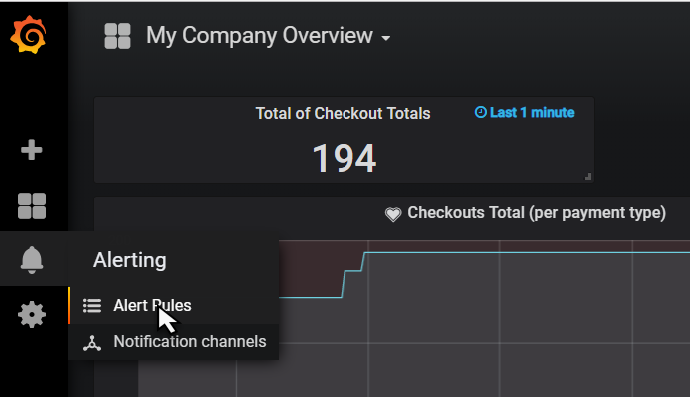
* add a panel of type Alert List

Do the latter:

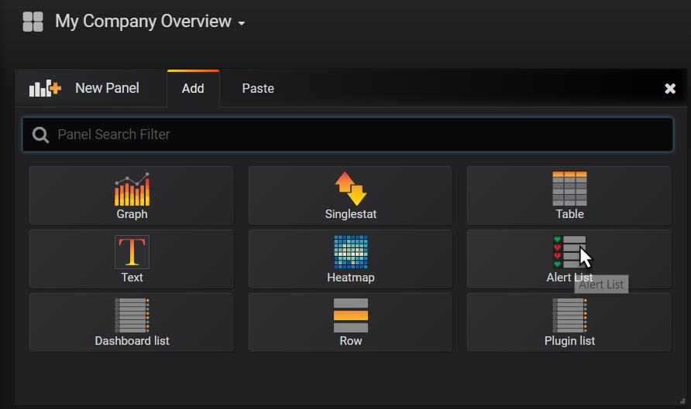

And when the alert is firing, you will see this:

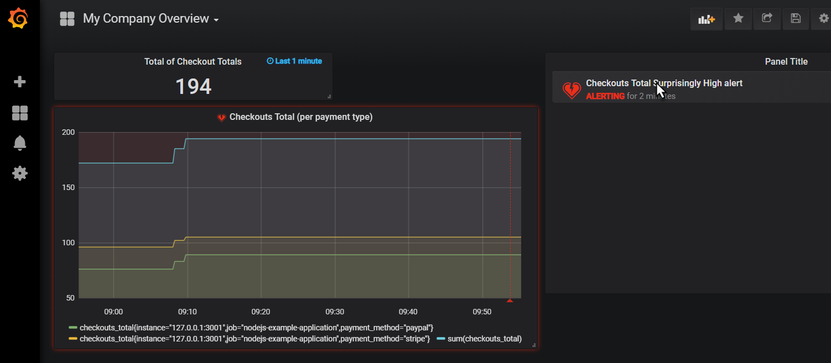

When you click on the active alert, you drill down to the alert definition in the panel editor:

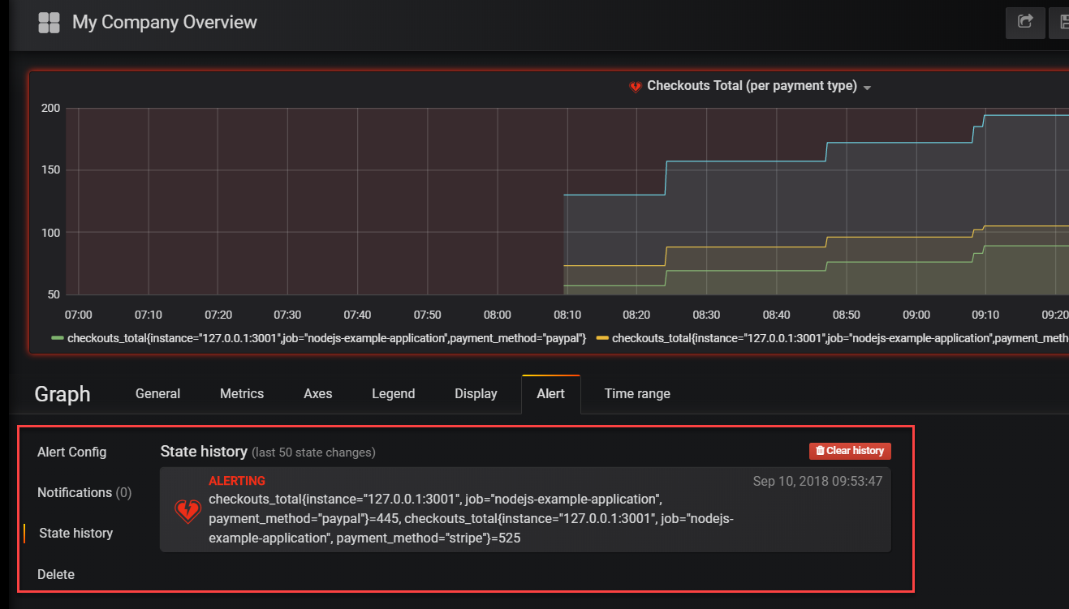

Here you can inspect details and check the history of the alert.

Note: just like in the Prometheus Alert Manager, you can configure notification channels and associate them with the alerts.

The Notification Channels are set up from the Alerting | Notification Channels option on the main menu.

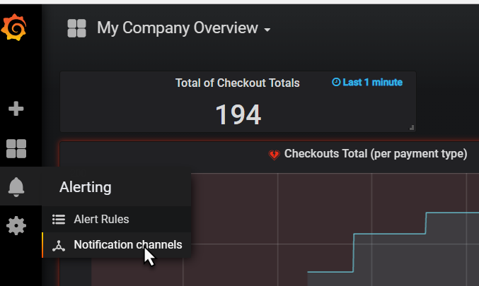

Grafana has out of the box support for a substantial number of notification and communication channels:

